Standard Advertisement Format
The contents of the advertisement to be placed are detailed in Regulation 5: Advertising. It should be noted that the prospective licensee must submit a copy of the newspaper advertisement to the Regulator within 14 days of its publication, that the advertisement must be placed in a national newspaper, and that the advertisement must state that objections must be submitted to the Regulator within 30 days of publication. An example of such an application advertisement is provided below. The ECB must pre-approve the advertisement and will give the go-ahead to the applicant to advertise.

All areas shaded yellow must be completed with the details of the applicant
ADVERTISEMENT IN TERMS OF SECTION 20 (1) (b) OF THE ELECTRICITY ACT, (ACT 4 OF 2007) AS READ TOGETHER WITH REGULATION 5 OF THE ADMINISTRATIVE ELECTRICITY REGULATIONS PUBLISHED IN TERMS OF SECTION 43 OF THE ACT IN GOVERNMENT NOTICE 13 OF 2011
NOTICE OF APPLICATION IS HEREBY GIVEN BY SIMPLE ENERGY (PTY) LTD FOR A GENERATION LICENCE FROM THE ELECTRICITY CONTROL BOARD ESTABLISHED IN TERMS OF SECTION 2 OF THE ELECTRICITY ACT OF 2007 (ACT 4 OF 2007)
In accordance with the requirements of Regulation 5(3)(a) and (b) the following information is specified:
Applicant: Simple Energy (Pty) Ltd
Country of Registration: Namibia Place your company logo here
Registration Number: xxxxx
Postal Address: xxxxxxx
Type of Application: Generation licence
Installed Capacity: 35MW
Technology: Solar PV
Location of Generation Station:
Plant Co-ordinates: (indicate 4 point coordinates)
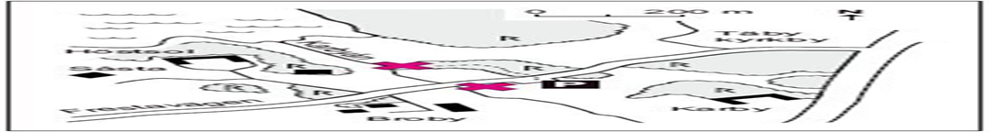
The following information will be available to any interested person to inspect the complete information in respect thereto at the physical address of the Electricity Control Board (ECB), No. 35 Dr. Theo-Ben Gurirab Street (former Burg Street) Klein Windhoek, Windhoek:
- Identity of the applicant, including certified copies of its constitutive documentation in the form of memorandum and articles of association, certified copy of certificate to commence business and signed resolution of board approving the submission of the application;
- Map showing the proposed location where Simple Energy (Pty) Ltd intends to erect the plant;
- Description of the technical design including a one-line diagram of the proposed plant and its surrounding electrical system.
- Description including the site layout of the area within which Simple Energy (Pty) Ltd intends to carry out activities authorized under the licence;
- Calculation of the net present value of the proposed plant;
- Complete list of tariffs which the applicant intends charging to be specified in the schedule of approved tariffs;
- Outline of intended operational and business plan;
- Desired licence period, including a motivation for such period, and an estimate of the expected income and expenditure of the undertaking to be carried out by the applicant;
- Such other information as the Electricity Control Board may require or as required in terms of the Electricity Act of 2007.
For interested parties to view the file for inspection, contact Mr. G. Nasima for an appointment at Tel: 061 374 300. Please note the ECB office hours 7h30-16h30. Any person wishing to object to this Application may within a period of 30 days after the date of publication of this advertisement lodge a written objection against such Application with the Electricity Control Board in a form determined by the Board and in compliance with the relevant provisions of Regulation 5 of the Electricity Administrative Regulations.

