DRAFT

Technical Report:

Training Needs Assessment of Southern Africa Regional Electricity Regulators Association (RERA)

Dr. Graeme Chown, Consultant
Maree Roos, Consultant
Alexander Filippov, Southern Africa Trade Hub

Submitted by:
AECOM International Development

Submitted to:
USAID/Southern Africa

November, 2014

USAID Contract No. 674-C-00-10-00075-00

Page intentionally left blank for printing so that Table of Contents will start on right-hand side of page

TABLE OF CONTENTS

TABLE OF CONTENTS 3
1. Introduction 5
1.1. Survey Objective 6
1.2. Survey Process 6
1.3. Survey Responses, Structure & Methodology 6
2. Current Capacity & Training Requirements 9
3. Traditional Regulation 12
3.1. Policy, Regulatory approaches and general understanding 12
3.2. Legal 12
3.3. Technical 13
3.4. Economic 13
3.5. Consumer 14
3.6. Oversight & Compliance 14
3.7. General Managerial 15
4. Evolving Regulation 16
4.1. Policy 16
4.2. Renewable Energy Implications 16
4.3. Embedded Generation 17
4.4. Technology Innovation 17
4.5. Evolving Market Structure 18
5. Core Competencies 19
5.1. Technical 19
5.2. Financial & Economic 20
5.3. General Business 20
6. Alignment with Regulatory Principles 21
7. Conclusions and Recommendations 22
7.1. Training Program Sustainability 22
7.2. Train the Trainer 23
7.3. Staffing & Vacancies 23
7.4. Training Methods & Curriculum 23
7.5. Traditional Regulation 24
7.6. Evolving Regulation 24
7.7. Core Competencies: 24
7.8. Alignment with key regulatory principles 25

1. Introduction
USAID Southern Africa Trade Hub (the Trade Hub) is working with governments and regional institutions, such as the Regional Electricity Regulators Association of Southern Africa (RERA), to strengthen capacity for regulating the clean energy sector in the region. Developing a transparent, robust and predictable clean energy regulatory regime in the region is critical to attracting Independent Power Producers (IPP) investment in the sector. An increase in IPP clean electricity generation will contribute to security of supply, climate change mitigation, economic growth, trade competitiveness, poverty reduction and food security in the region.

The Southern African Development Community (SADC) Ministers responsible for Energy established the Regional Electricity Regulators Association of Southern Africa (RERA) as a formal association of electricity regulators The Association was established in terms of the SADC Protocol on Energy (1996), the SADC Energy Co-operation Policy and Strategy (1996), the SADC Energy Sector Action Plan (1997), the SADC Energy Activity Plan (2000) and in pursuit of the broader initiative of the New Partnership for Africa’s Development (NEPAD) and the African Energy Commission (AFREC).

In this context RERA’s mandate is to ensure:

Capacity Building & Information Sharing
Facilitate electricity regulatory capacity building among Members at both a national and regional level through information sharing and skills training.

Facilitation of Electricity Supply Industry (ESI) Policy, Legislation and Regulations
Facilitate harmonized ESI policy, legislation and regulations for cross-border trading, focusing on terms and conditions for access to transmission capacity and cross-border tariffs.

Regional Regulatory Cooperation
Deliberate and make recommendations on issues that affect the economic efficiency of electricity interconnections and electricity trade among members that fall outside national jurisdiction, and to exercise such powers as may be conferred on RERA through the SADC Energy Protocol.

The Trade Hub is providing technical assistance to RERA to institutionalize a long term sustainable training program. The program will improve on RERA’s past approach to training, make training courses more predicable (announced in advance) for better planning by the members, and create a stable pool of experts accessible by RERA and member regulators on a as needed basis for regional and in-country regulatory trainings. In addition, the design of the program will be based on sustainability principles.

As a first phase of this effort, the Trade Hub assisted RERA in updating its standard Capacity Needs Survey. Given this context RERA members are obliged to collect and submit survey data to help achieve the SADC Ministers objectives. This Capacity Needs Assessment Report is based on the RERA Members’ responses to the new Capacity Needs Survey.

Survey Objective
The goal of this activity is to establish a regional platform for sustainable long-term capacity building for RERA’s regulatory agencies board members, commissioners, and other technical and support staff.
Specifically, this survey is the cornerstone of a needs assessment, which is ultimately geared towards designing a focused training program curriculum that would allow RERA to consistently address various training needs of its Members, ranging from core competencies to evolving regulatory issues.
There is significant global change in the skills requirements of energy regulators as markets evolve and renewable energy becomes ubiquitous. Additionally, the Commissioners change frequently, new regulators are being established, and newly established regulators are expanding. The capacity of the Boards, Commissioners, and other technical and support staff of the regulatory agencies to apply best practices are crucial for efficient and consistent formulation of energy policy direction, regulation, and management. In addition, the accelerated evolution and development of renewable energy markets, distributed generation, increased demand-side participation and smart grids, amongst other factors, also serve raise the importance of training, skills development, capacity building and information sharing as a continuous activity for RERA members.

Survey Process
The survey questionnaire was developed as a basis for surveying and assessing the capacity, capabilities, skills and training needs to equip regulators to carry out their expanding and increasingly complex roles and growing mandates. The survey replaced the old RERA’s survey of 2011.
The questionnaire was developed in MSWord and distributed to the RERA members, who returned the completed surveys via email, to USAID Southern African Trade Hub – the organisation tasked with developing, managing and reporting on the project. Once the completed questionnaires were received, the results were entered into a MS Excel workbook, designed to tabulate and display the results.
In conducting the assessment, respondents representing the key functional areas within each regulator were requested to fill in as much of the survey as possible.
The interim results of the survey were reported at RERA’s meeting of Human Resources representatives as part of the RERA Portfolio Committee on Capacity Building and Information Sharing work.

Survey Responses, Structure & Methodology
The survey was distributed to all RERA members and was completed by 100% of participants, i.e. by 10 current RERA’s Member Regulators. The survey can therefore be said to be fully representative with no issues of bias, undercoverage or non-response.
Figure 1: RERA training survey responses
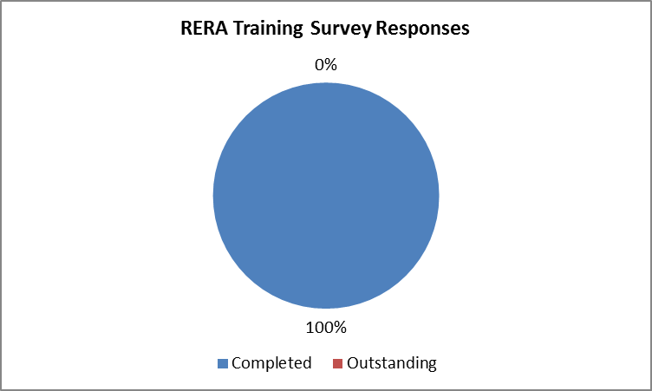

All of the respondents surveyed regulate the electricity sector, with some members also responsible for water, petroleum, gas and sewerage.
Figure 2: Sectors regulated
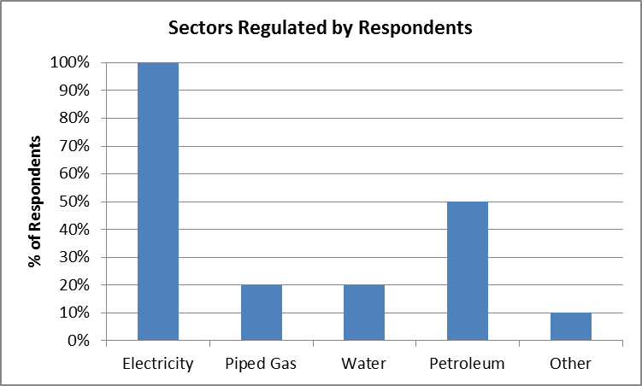
The survey assessed the regulator’s skills across several topics including policy, economic, technical, legal, consumer, oversight/compliance and general management. As such, different sections of the survey may need to be completed by different departments or portfolios within the regulator.
The survey questionnaire was structured to provide an assessment of the traditional skills and needs of an energy regulator, the evolving needs due to emerging issues and changes in market structure and technology as well as areas representing regulatory core competencies.
This survey was designed as a “self-assessment” with questions structured using a “Likert-type” scaling - a bipolar scaling method, measuring either positive or negative response to a statement. In this case the respondents were asked to rate their ability along the areas mentioned above.
Whilst it is clear that each respondents response is relative, the survey is intended to identify common areas that require training by grouping responses and interrogating the overall group response.
All survey responses are confidential and the results are all aggregated.

Current Capacity & Training Requirements
The first portion of the survey was designed to investigate the current status of capacitation within the members, as well as asking for preferred training methods as a means of informing the design of future training programs.

Figure 3: Staff distribution by gender and focus
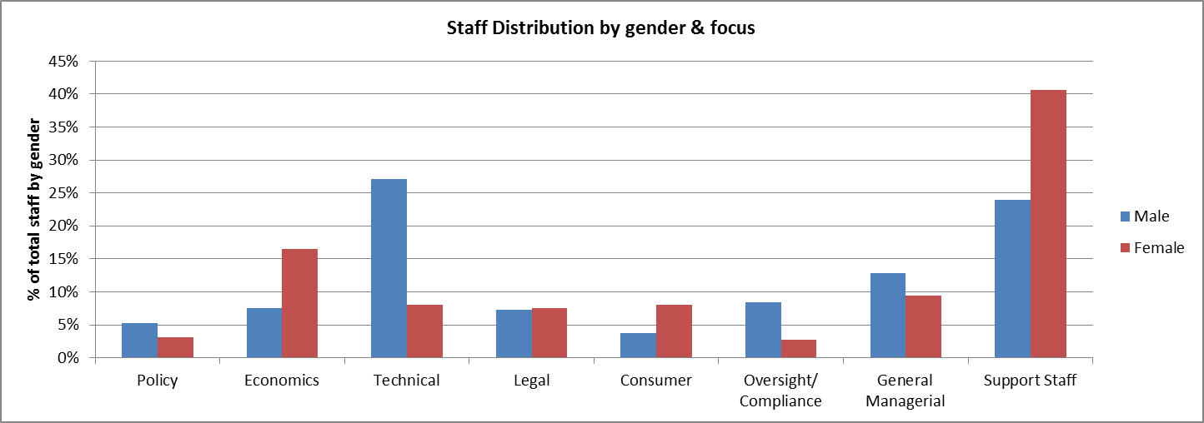

It is clear that there are some disparities in certain areas between male and female staff members. Of total staff in the respondents, 343 (60%) were male and 224 (40%) were female. There are also 109 vacant positions waiting to be filled amongst the RERA members.

Figure 4: Vacant positions by area
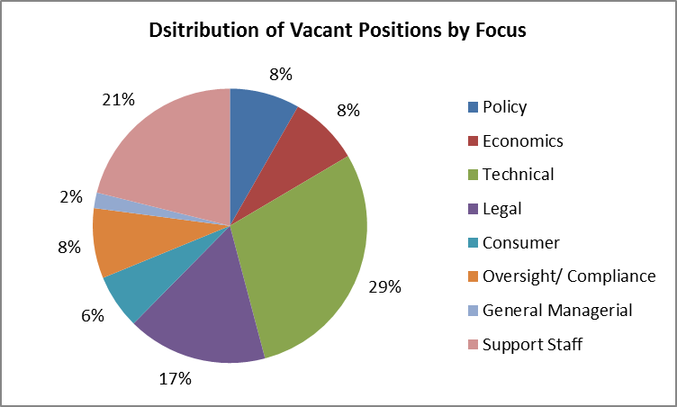

The majority of non-support staff vacancies were in the Technical and Legal areas, with a spread of other areas also requiring further capacitation.
Figure 5: staffing adequacy
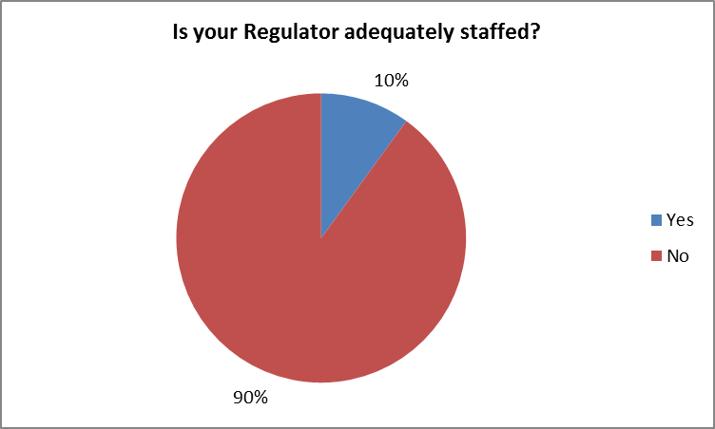

This is further supported by the overwhelming majority of respondents that felt their regulator was understaffed. Critical staffing requirements exist across several vital functions – this is one of the key themes that emerge from the survey responses: there currently exists a wide disparity between both skills and areas of expertise in most of the respondents. There are few areas that stand out as not requiring some form of training or support in the future.
Figure 6: Critical staffing requirements
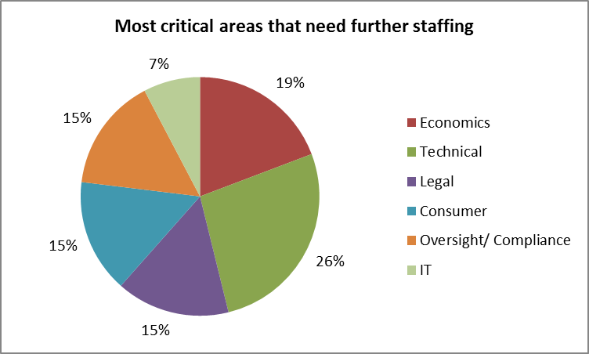

Respondents were immediately asked to indicate where they felt further training was required before the survey tested this in detail. The response depicted a wide variety of areas that needed further training – this is once again due to the wide range of skills levels and areas of expertise amongst regulators, which is also supported by the ranges of responses in the detailed questions that follow.
Figure 7: Critical training requirements
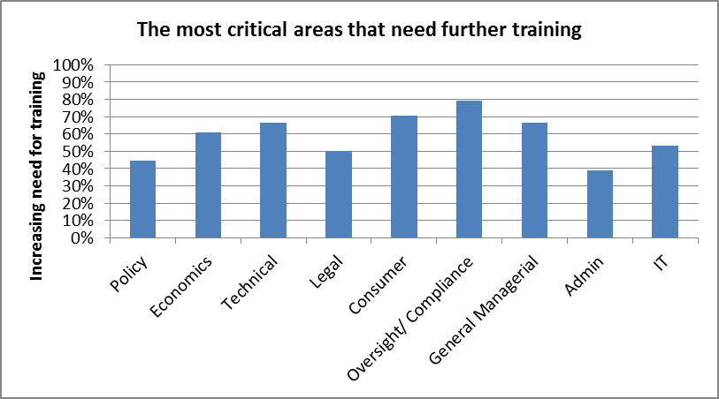
An increasing need for training was required for all areas, but Technical, Consumer and General Managerial training was highlighted. It is not clear what General Managerial training is required, as the respondents rated themselves as competent with regards to General Business, later on in the survey – this should be interrogated further with RERA members to gain clarity.
Figure 8: Preferable Training Methods
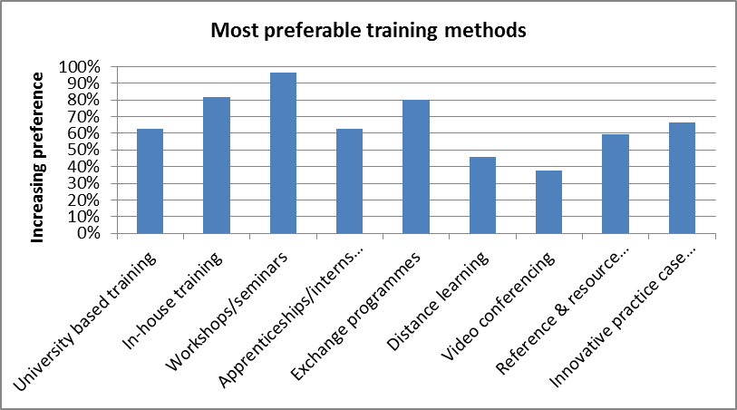

Finally, respondents were asked for a preference with regard to training methods. Once again there is a fairly wide spread of preferences, but in-house training via workshops/ seminars, case studies and exchange programmes were viewed as most preferable. It is recommended that future training programmes are developed using these; however the increasing preference for university based training may also be indicative of a lack of a pool of skilled resources in general in certain countries.

Traditional Regulation
The survey distinguished between “Traditional Regulation” and “Evolving Regulation” in order to determine training requirements for both areas.

Policy, Regulatory approaches and general understanding
Figure 9: Policy, regulatory approaches and general understanding
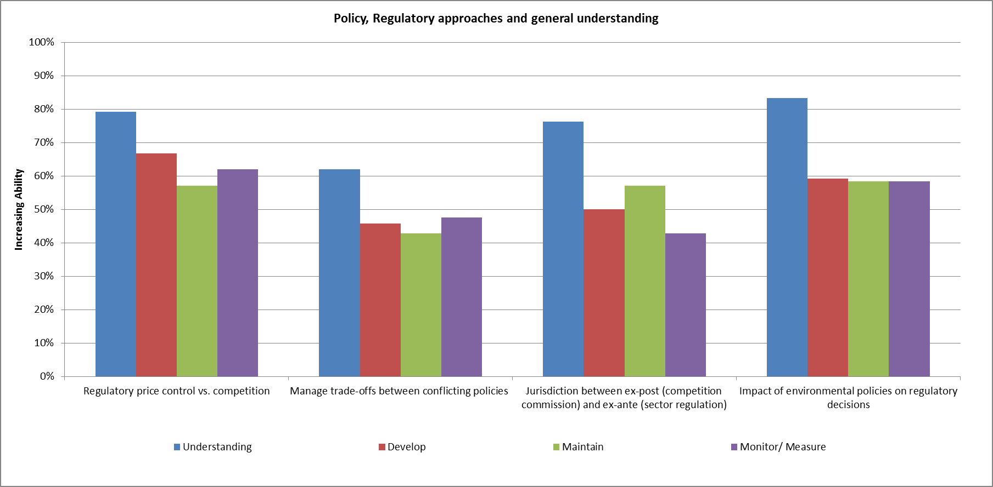
There is clearly a good overall understanding of the role of regulation within the electricity industry, with over 50% ability across all topics. However; respondents feel that they are less able to translate that understanding into development, maintenance and monitoring of (for example), policies, rules and regulations in the areas queried.

Managing trade-offs between competing policies e.g. environmental & industrial development, as well as the difference between ex-post and ex-ante regulation, stand out as the two areas that could use some support.

Legal
Figure 10: Legal issues
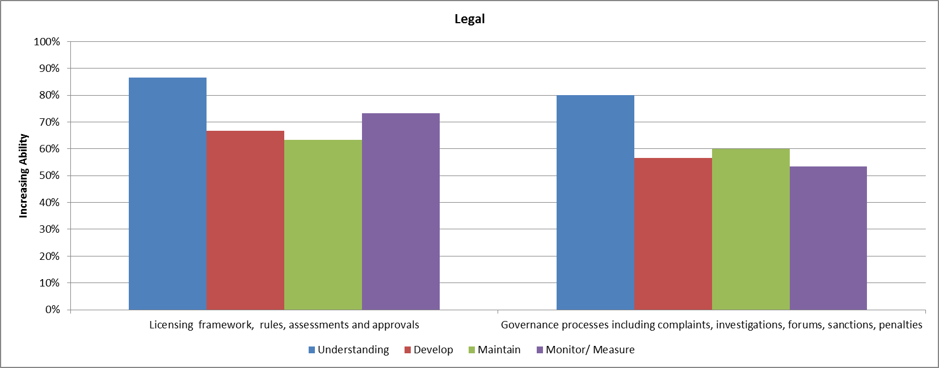

Legal issues associated with traditional regulations were seen as well understood and managed. There was less ability with regard to governance processes and the implementation of penalties and sanctions as a result of complaints and investigations. This is a highly specialised area of regulation and it is expected that regulators will seek specialist advice – however the development of these governance regimes is the responsibility of the regulator and this must be ensured through appropriate training support.

Technical
Figure 11: Technical Issues
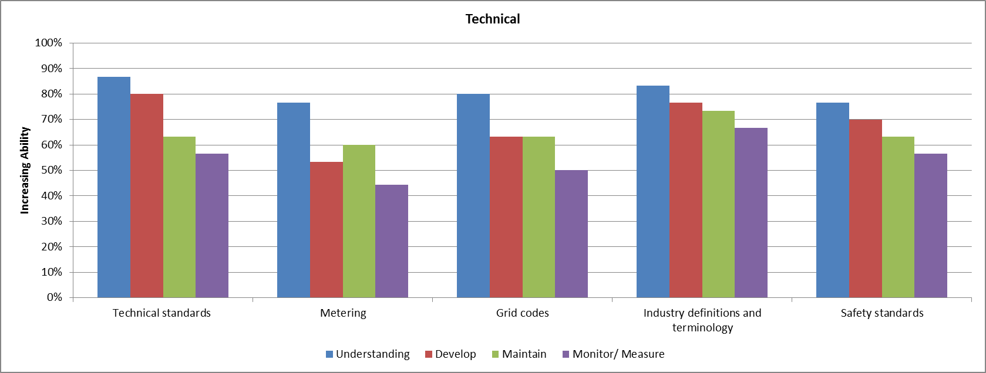

Although respondents earlier highlighted technical training as an area that required further support, their specific self-assessment rates the current status of technical ability as being relatively high across traditional areas of regulation.
Metering and monitoring of grid code compliance are the least skilled areas in this section. It should also be noted that across almost all areas in the survey there is decreasing ability as the respondents move from measuring their “understanding” of a topic through to “monitor/measuring”. This seems to indicate that respondents are comfortable conceptually, but often lack the skills to implement and manage ongoing regulatory requirements.

Economic
Figure 12: Economic Issues
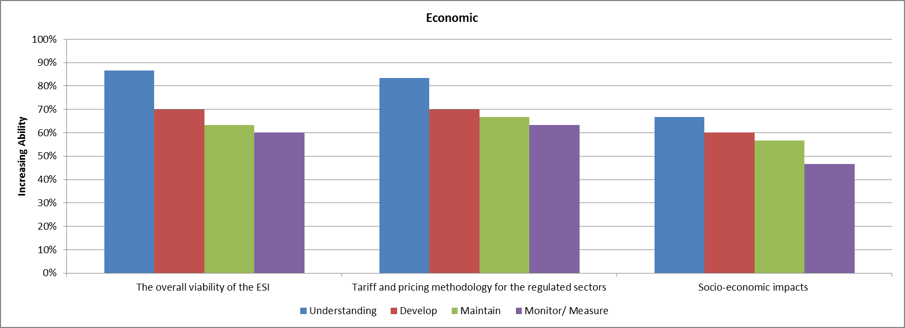
Over 11% of all respondents staff were categorised as being responsible for regulatory economic issues. General understanding is relatively high, however there is some requirement of further training around socio-economic impacts, which is also closely linked with understanding policy trade-offs (mentioned previously as needing further training). These two areas can be linked in future training programs.

Consumer
Figure 13: Consumer Issues
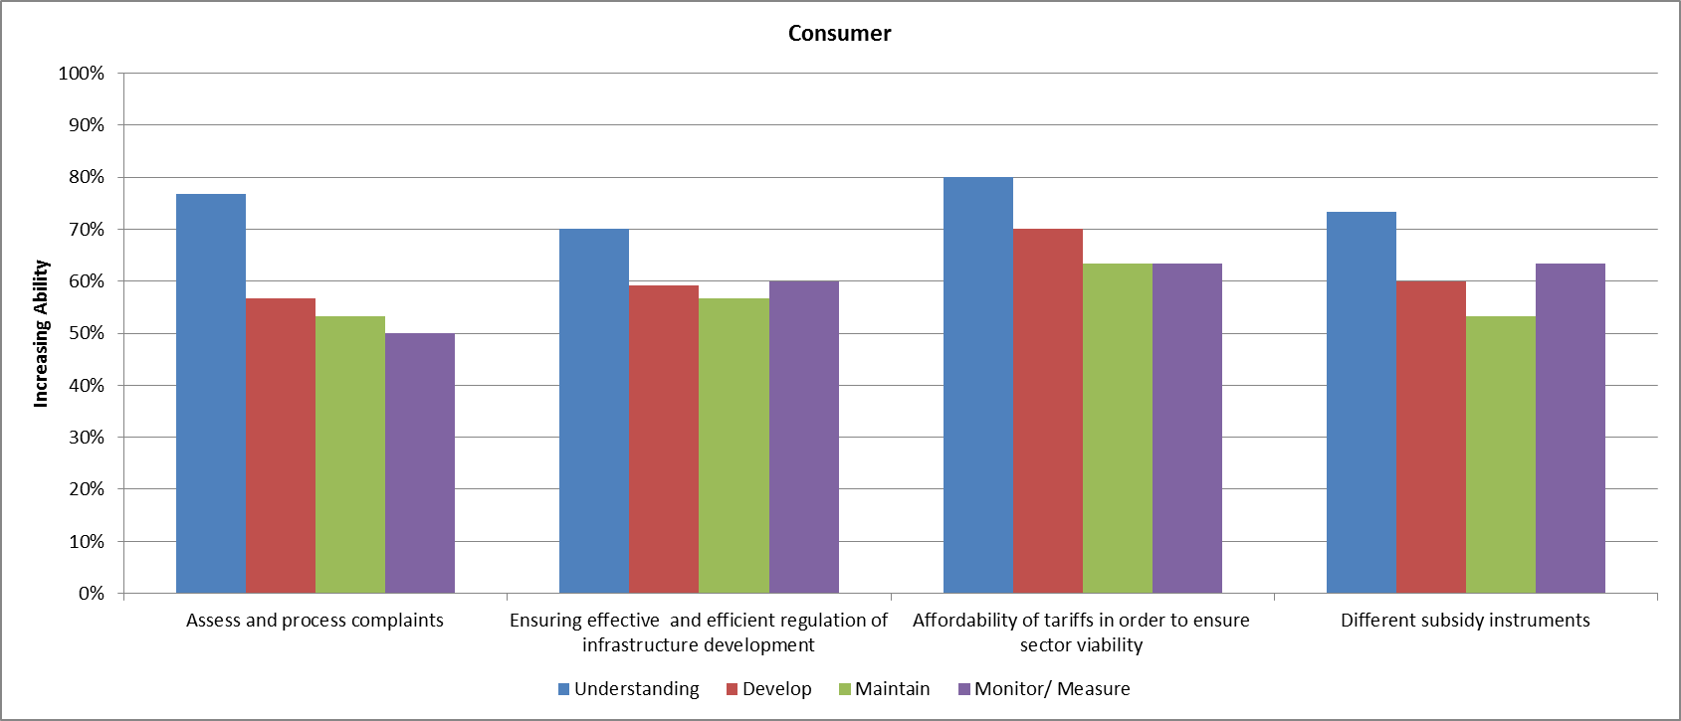

Consumer related issues were highlighted in all sections as being critical areas that require improvement – from both training and staffing point of view. Subsidy instruments and processing of complaints are highlighted as the main areas requiring attention – subsidies will also from a part of the issues regarding socio-economic impacts and policy trade-offs.

Oversight & Compliance
Figure 14: Oversight & Compliance Issues
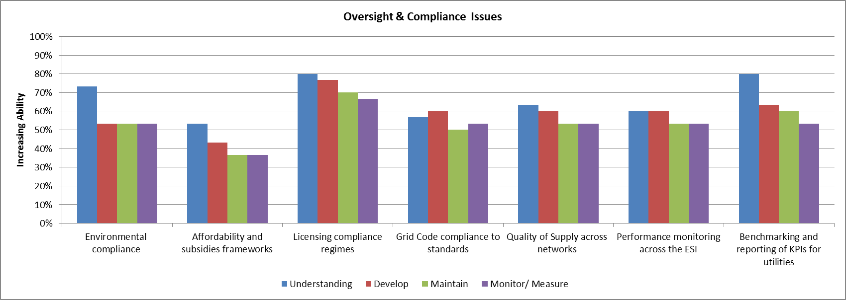
This area scored relatively low overall excepting for the issues around licensing compliance. The issues of compliance as it relates to subsidies scored the lowest and is clearly an area which requires support. Most of the areas scored at average (50%) ability and this entire section should be earmarked for further investigation regarding future training.

General Managerial
Figure 15: General Managerial Issues
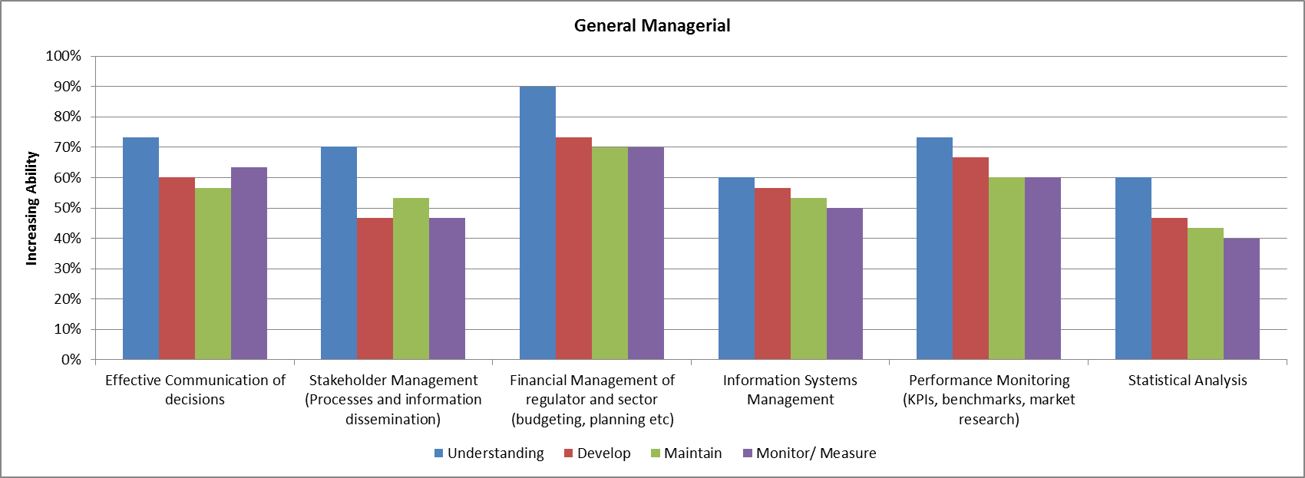

General managerial skills were relatively high across common functions such as financial management and budgeting. An emerging theme from these questions was the requirement for further assistance with regard to data, analysis and Information Systems support. Interestingly, stakeholder management processes has been highlighted as another area to be considered for future training.

Evolving Regulation
The questions in this section were intended to gauge the level of ability respondents had with emerging market structures, technologies, innovation and trends in the electricity supply industry.

Policy
Figure 16: Evolving Policy
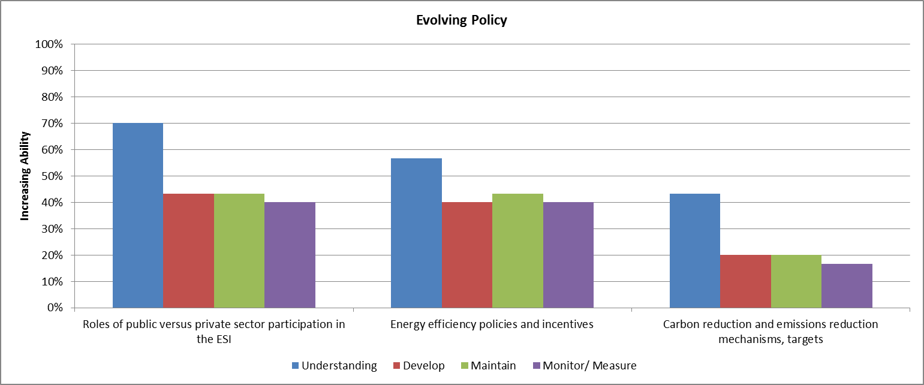
The role of Independent Power Producers (IPPs), carbon taxation and energy efficiency have become increasingly important over the past 5-10 years. The low scores in this area indicate that these are issues which need to be addressed immediately through training and education.

Renewable Energy Implications
Figure 17: Renewable Energy Implications
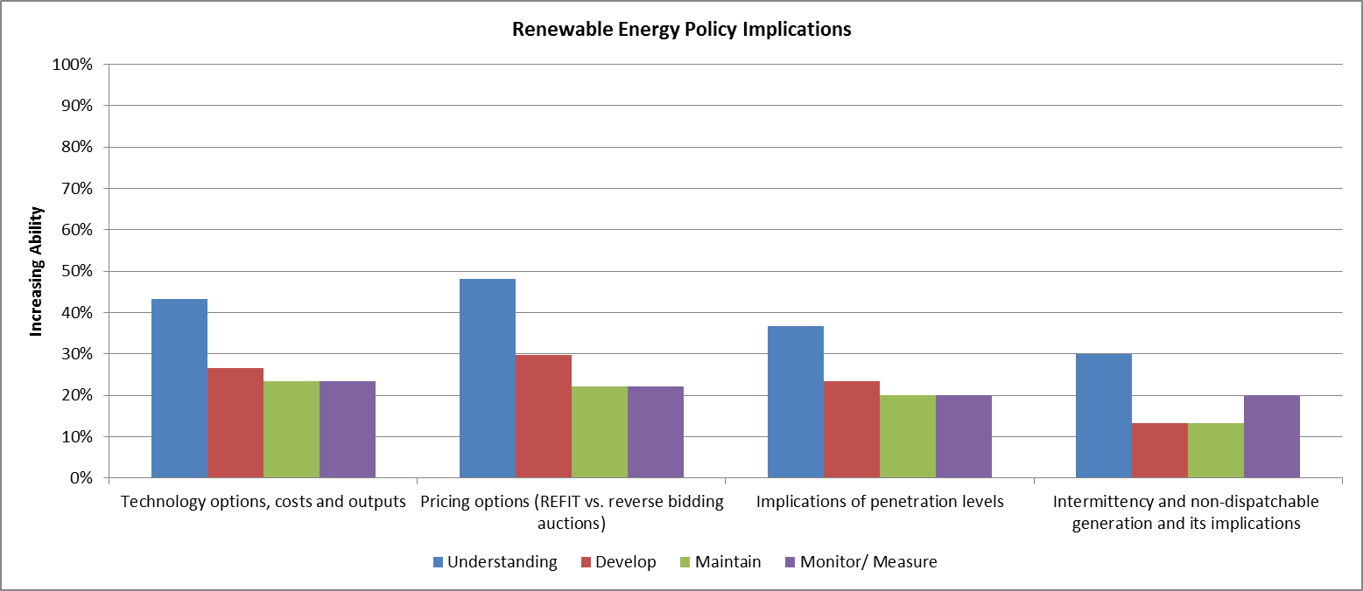
Similarly, the scoring on ability of renewable energy implications is extremely low, especially as compared with scoring in the traditional areas of regulation. It is understood that this area has only recently become an important component of the regulators ambit; however the impact of renewable energy and evolving market structures is another key theme emerging from this evolving policy section that requires further appropriate support.

Embedded Generation
Figure 18: Embedded Generation
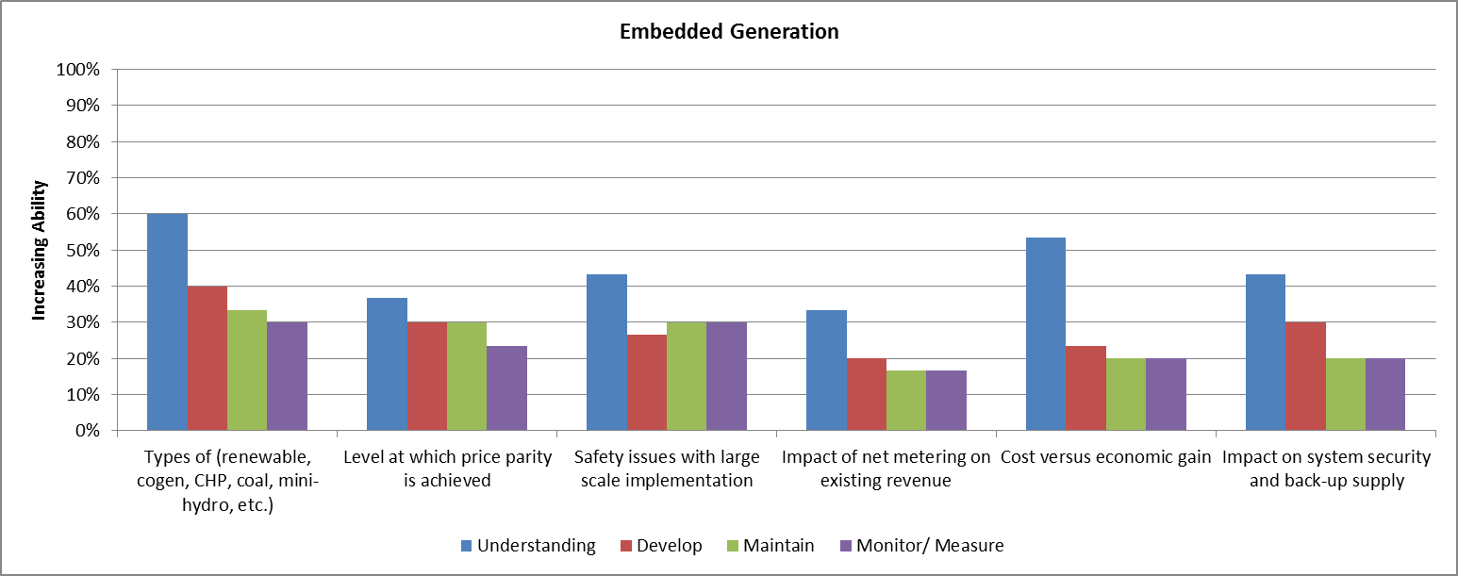
The increasing number of renewable and cogeneration projects has also led to an increase in embedded generation i.e. distributed generation “behind the meter”. It is clear that this is another area which requires upskilling for regulators given the low ability scores.

Technology Innovation
Figure 19: Technology Innovation
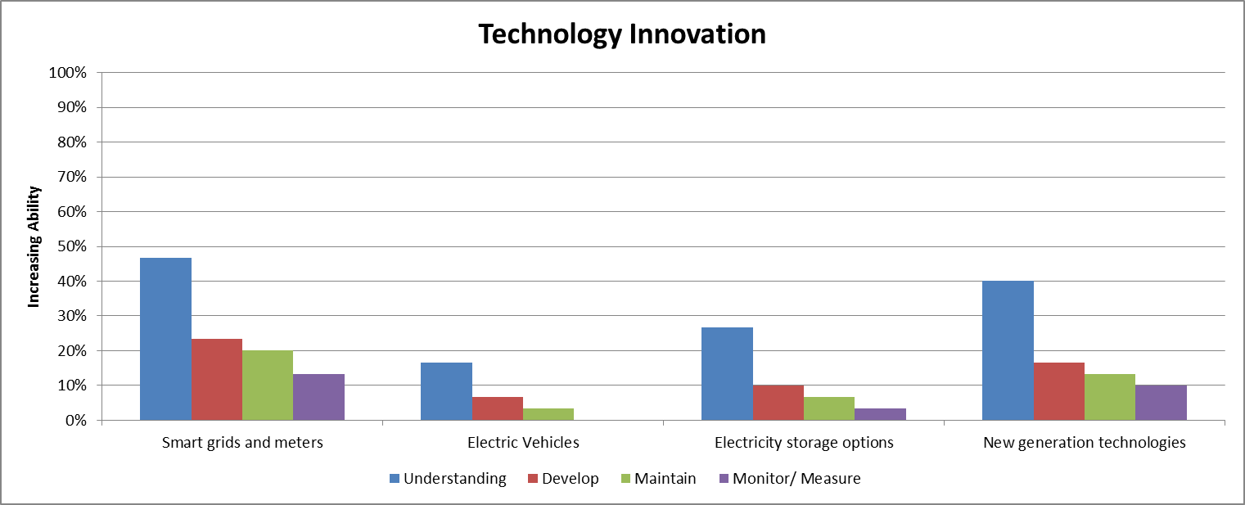
This area scored lowest out of the entire survey. It could be argued that for many of the respondents, that electric vehicles are not currently significant; however smart grids & meters as well as storage options will become critical in the medium term for most countries globally.

Evolving Market Structure
Figure 20: Evolving Market Structure
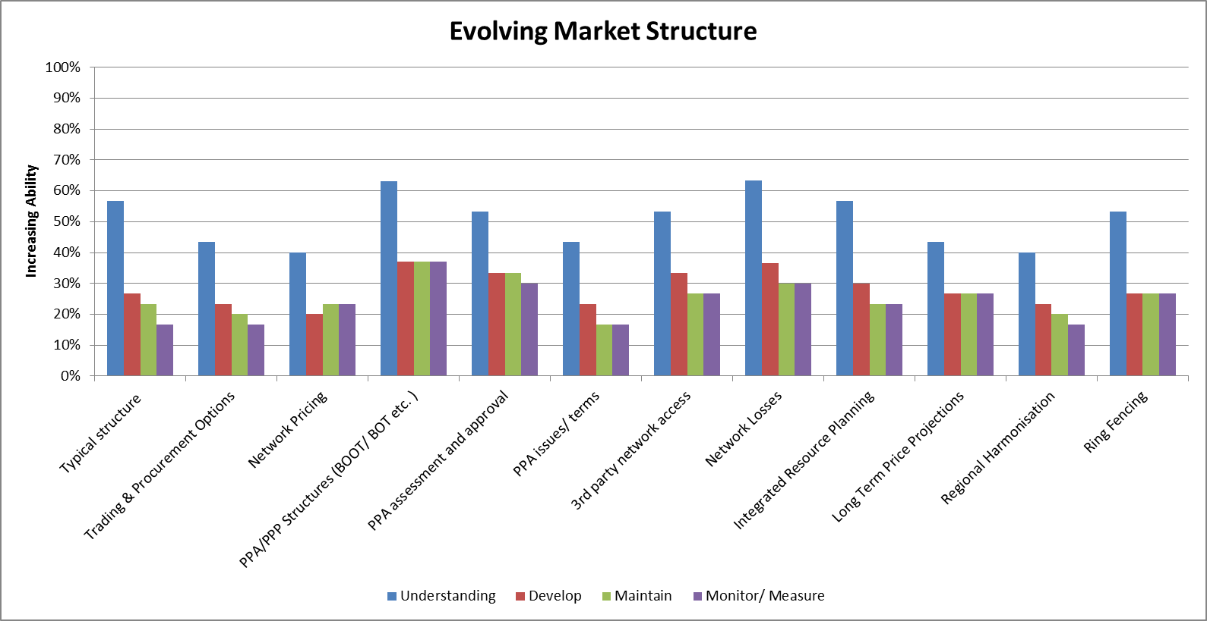

There are several technical and commercial outcomes due to the evolving market structures currently taking place. As IPPs increase and procurement practices change, regulators will need to upskill in various areas. The scoring in this section indicates that once again there is a good high level understanding of the concepts, but no real ability to put these into practice. PPA terms, trading options and regional harmonisation scored the most poorly in terms of current ability.

Core Competencies
Along with measuring key focus areas of traditional and evolving regulation, the survey also tested each respondent’s core internal competencies, i.e. those skills and abilities that can be used in a variety of different focus areas.

Technical
Figure 21: Technical Competencies
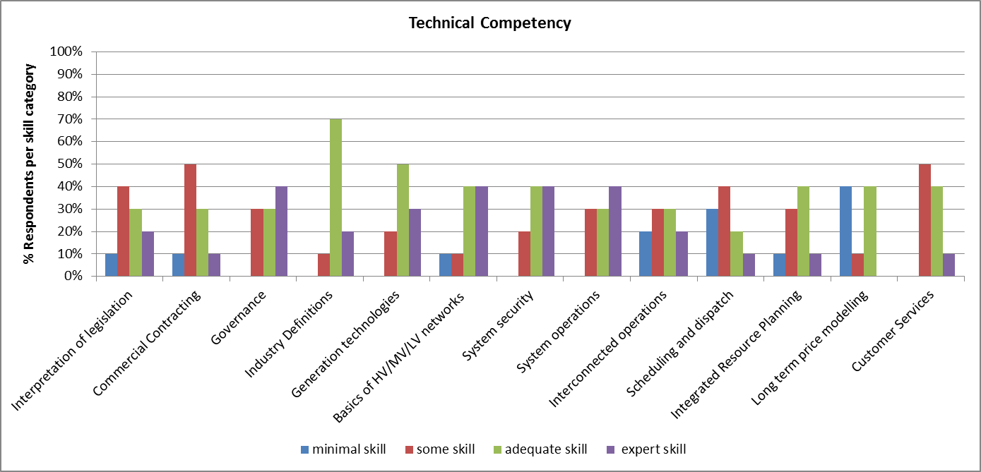

It is interesting to note the wide dispersion of skill levels across the various areas. As mentioned previously, there are clearly pools of skills in some areas and within some regulators, but no consistent skills level across all regulators.
There are few areas in which the majority of respondents answered with “expert” or “adequate” skill. It may be worthwhile to first target those areas where there is evidence of both “some” and “minimal” skill first.
Whilst some of the regulators feel that they have “adequate” skill, it is also not clear whether or not these skills are being used. In the case of Long term price modelling, almost half of the respondents felt they had adequate skill; however none of the RERA members publishes long term price projections.
Scheduling and dispatch is the weakest competency in this section.

Financial & Economic
Figure 22: Financial & Economic Competence
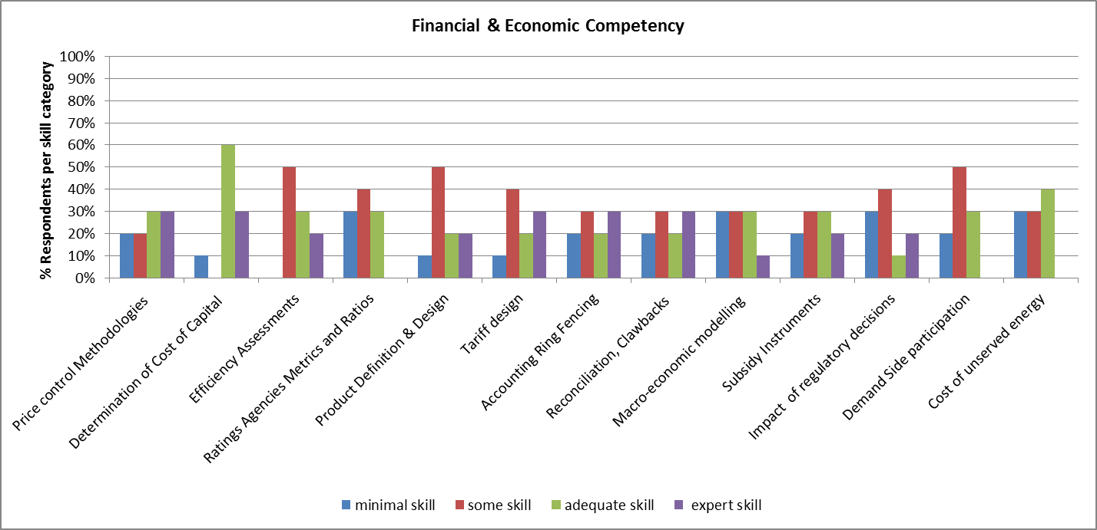
Once again, It is clear from the distribution of responses that skills levels vary significantly between RERA members – each of the areas surveyed has some response of “minimal” or “some” skills. Determination of the Cost of Capital stands out as a strong are of financial and economic competence. All the other areas require some support – special attention should be given to Impact of regulatory decisions, which is also linked to our earlier comments on socio-economic impacts and policy trade-offs.
Overall this area has low levels of competence.

General Business
Figure 23: General Business Competence
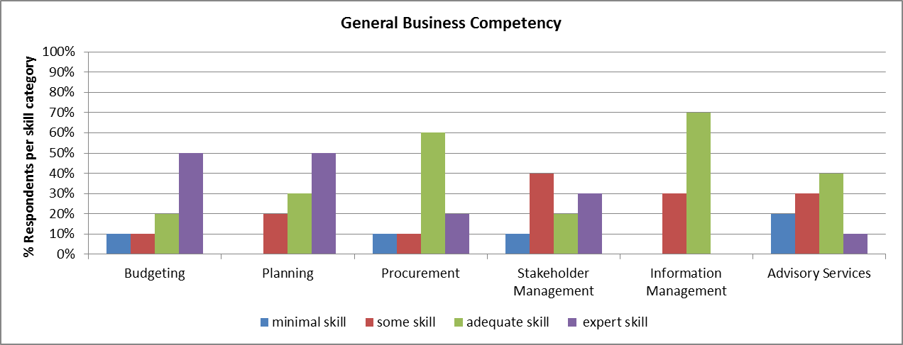
Overall this area has relatively strong competency, although not amongst all regulators. Stakeholder Management and Advisory Services seem to require the most immediate attention.

Alignment with Regulatory Principles
As a final question, respondents were asked to measure their alignment with key regulatory principles as has been discussed previously within RERA.

Figure 24: Alignment with regulatory principles
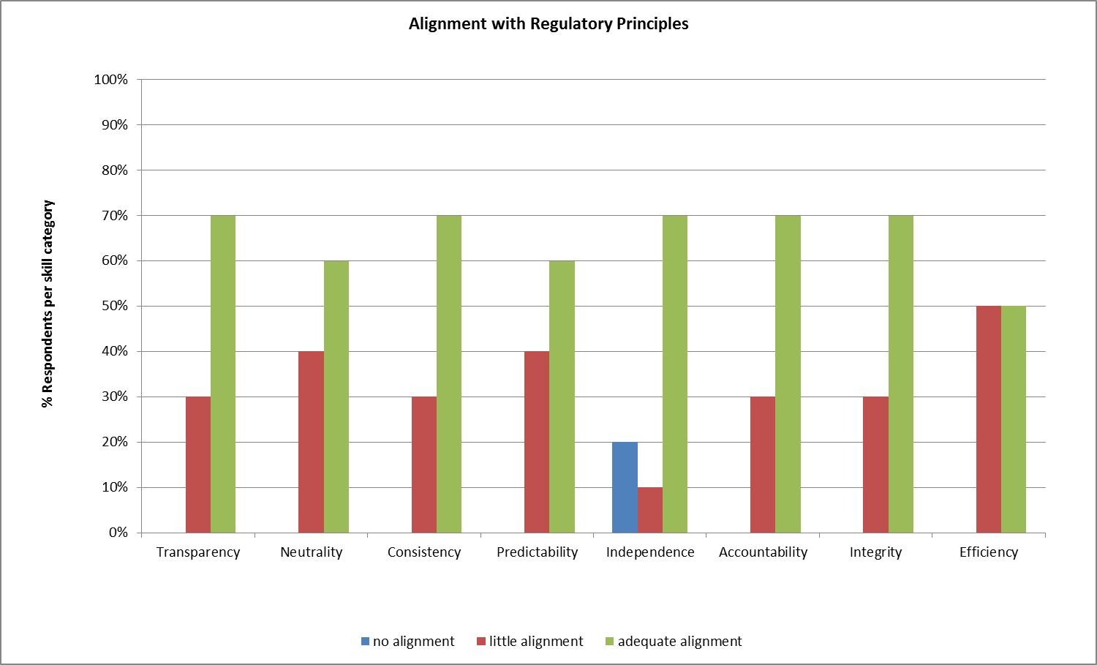

Across all the principles there are respondents that feel they have little alignment with these principles – this is due to a number of reasons including political involvement, the varying weights placed on particular issues by the different stakeholders involved and the tension between policy, regulation and legislation which are often misaligned.
It is not clear that these issues can be addressed via a training program; however it is worth noting that with on-going training and empowerment of regulators, this misalignment should decrease over time.

Conclusions and Recommendations
The survey was completed by all respondents and with almost all areas fully completed. From this point of view, the survey can be said to be fully representative of the RERA members. This is positive as it provides a means of creating a benchmark to measure future improvements as a result of any training program implemented. In order to measure progress and ensure that training material is relevant this survey should be run on an annual or bi-annual basis.

Training Program Sustainability
The survey and present capacity needs assessment were undertaken as part of institutionalizing a sustainable long term training program within RERA. The following table describes the process required to ensure this training program’s longer term sustainability.

 | Steps | Comment
1 | Use survey results to identify specific training interventions. | Completed – results to be disseminated to RERA members via final report and presentation.
2 | Secure funding for development, scheduling and delivering of training programs. | Next step to be undertaken by RERA
3 | Develop training programs and material that are aligned with Observations/Recommendations from this survey. | High level outlines are provided in the final survey report. Also need to appoint the RERA trainer that will be responsible for each workstream.
4 | Schedule training programs. | Based on outcome of step 3.
5 | Deliver training programs in accordance with schedule. | On-going program to be updated annually by RERA trainer.
6 | Monitor success of training programs. | Ensure collection of short-term feedback on each specific program.
7 | Performing training assessment every 2nd year. | Re-run annual survey to benchmark improvement.
8 | Repeat cycle.
Table 1: Process to ensure training program sustainability

Train the Trainer
Successful training is the result of repetitive and consistent application by qualified, experienced and motivated individuals. Each of the focus areas tested in this survey will require on-going development of material as the sector adapts and changes. This in turn implies that there is a focus area “champion” dedicated to maintaining the material and implementing the training.

Recommendation 1:
The most effective means for this training to be maintained and developed over the period required to ensure that it is managed by RERA members themselves. It is therefore recommended that a “train-the-trainer” approach is adopted: specific individuals that display interest or expertise in particular fields will be trained and will then in turn train other staff members from RERA’s members. In this way the training is absorbed and becomes part of RERA itself and not something that needs to be continually managed and updated by 3rd parties.

Staffing & Vacancies
Approximately 16% (109) of total staff requirements are currently vacant. The vacant positions are also spread over several focus areas and cannot therefore be dismissed as merely relating to, for example, support staff. If these vacancies are not filled, this will lead to longer term underperformance.
Recommendation 2:
Investigate training requirements to improve on Human Resources functions within regulators. Identify potential individuals that can be upskilled or that require further training in order to fill vacancies. RERA members to compile a list of staff members that can be sent on HR training and identify any staff that could fill vacant positions through further training and support. Special attention to be paid to Technical and Legal training requirements as these comprises the majority of current vacant positions.

Training Methods & Curriculum
Respondents indicated that training was most critical in the following areas:
- Oversight/Compliance
- Consumer
- Technical
Thereafter:
- General Managerial
- Economic
Recommendation 3:
Oversight/Compliance and Consumer related issues were highlighted throughout the survey and can be addressed through immediate training. However; as with Technical, these are wide areas and it is clear that respondents have a fair high-level understanding. Training therefore needs to be targeted to specific issues in order to have the most impact.
In-house workshops, case studies, exchange programs and a practical approach were most preferred by RERA members and any training programs should be structured accordingly.

Traditional Regulation
Three key themes emerged from this area:
- Managing trade-offs between competing policies
- Creating, managing and monitoring of subsidy instruments
- Managing governance and consumer related issues such as complaints
Recommendation 4:
There are various case studies and examples of best practice that can be identified and adapted for RERA members use. Training should focus on providing the regulator with the tools required in order to allow them to provide input to their constituents on the impact of decisions resulting from policy trade-offs and subsidy instruments. Regulators must therefore be empowered to understand, analyse and explain the outcome of the various decisions taken by policy makers.
A separate training stream can be developed to address governance and consumer related issues which is a general weakness in the sector.

Evolving Regulation
As is expected, the level of ability within this area was considerably weaker relative to traditional regulation. Training and support programs can be developed across all the areas surveyed.
Recommendation 5:

Develop the following training programs for dissemination:
- Evolving Policy: Private vs. Public Sector, Energy Efficiency, Carbon
- Renewable Energy: Technologies, Pricing/ Costs, Market Implications, Intermittency
- Embedded Generation: Pricing, Safety, Wheeling, Revenue Impact, Quality and Security of Supply
- Innovation: Smart Grids & Meters, Storage, New Technologies
- Evolving Market Structures: Trading & Procurement, Network Pricing, PPAs, 3rd Party access, Losses, Long Term Pricing, Ring Fencing, Regional Harmonisation

Core Competencies:
Respondents were measured against Technical, Economic & Financial and General Business. There was a wide spread of abilities against all areas examined with very few competencies where all responses were either “adequate” or “expert”. This training program cannot be expected to address all the underlying technical, economic, financial or business competencies required, but it can address some specific issues within those areas.
Recommendation 6:
Create training programs for the top 3 areas requiring support in each competence area:
- Interconnected Operations (Technical)
- Scheduling & Dispatch (Technical)
- Long Term Price Modelling (Technical)
- Rating Agencies Metrics & Rations (Economic & Financial)
- Subsidy Instruments (Economic & Financial)
- Impact of Regulatory Decisions (Economic & Financial)
- Procurement (General Business)
- Stakeholder Management (General Business)
- Advisory Services (General Business)

Alignment with key regulatory principles
The following key regulatory principles have been assessed:
- Transparency
- Neutrality
- Consistency
- Predictability
- Independence
- Accountability
- Integrity
- Efficiency
There is some misalignment with these principles and it is proposed that this can be improved by further training and empowerment of regulators, especially with regards to certain sensitive issues relating to socio-economic issues and policy trade-offs.
Recommendation 7:
Check alignment in the next survey as a litmus test of the ongoing improvement of the RERA members.

