Technical Support for Continued Support on Regional Market Framework Implementation to the Regional Electricity Regulators Association of Southern Africa (RERA)
Dispatch and Curtailment Risk Guidelines

Prepared for: Prepared by:
Office of Energy Programs Deloitte Financial Advisory Services, LLP
Bureau of Energy Resources 1919 N. Lynn Street
U.S. Department of State Arlington, VA 22209

November 07, 2018
This work was funded by the U.S. Department of State, Bureau of Energy Resources, Power Sector Program. This work does not necessarily reflect the views of the United States Government.

DISCLAIMER
This document has been prepared by Deloitte Financial Advisory Services LLP (“Deloitte FAS”) for the U.S. Department of State (“DOS”) under a contract between Deloitte FAS and DOS. This document does not necessarily reflect the views of the Department of State or the United States Government. Information provided by DOS and third parties may have been used in the preparation of this document but was not independently verified by Deloitte FAS. The document may be provided to third parties for informational purposes only and shall not be relied upon by third parties as a specific professional advice or recommendation. Neither Deloitte FAS nor its affiliates or related entities shall be responsible for any loss whatsoever sustained by any party who relies on any information included in this document.
TABLE OF CONTENTS
EXECUTIVE SUMMARY 6
1. Background on dispatch and curtailment 7
2. REVIew of International leading Practices for covering Dispatch and Curtailment RisK 7
NERC (United States and Canada) 7
ENTSO-E (Europe) 13
3. Identification and MITIGATION of dispatch and curtailment risk 16
4. PROPOSED dispatch and curtailment risk GUIDELINES 19
5. Next Steps 30

Acronyms
ACER | Agency for the Cooperation of Energy Regulators
DAFD | Day-Ahead Firmness Deadline
DAM | Day-Ahead Market
DOS | U.S. Department of State
ENR | Bureau of Energy Resources
ENTSO-E | European Network Transmission System Operators - Electricity
EC | European Commission
EU | European Union
FERC | Federal Energy Regulatory Commission
IDM | Inter-Day Market
ISO | Independent System Operator
MO | Market Operator
NDA | Non-Disclosure Agreement
NERC | North American Electric Reliability Corporation
PSP | Power Sector Program
PTR | Physical Transmission Rights
RTO | Regional Transmission Operator
RERA | Regional Electricity Regulators Association of Southern Africa
SADC | Southern Africa Development Community
SAPP | Southern Africa Power Pool
SAPP CC | Southern Africa Power Pool Coordination Center
TSO | Transmission System Operator
UIOLI | Use-It-Or-Lose-It
U.S. | United States
VRE | Variable Renewable Energy

1EXECUTIVE SUMMARY
Work under Technical Support for Continued Support on Regional Market Framework Implementation to the Regional Electricity Regulators Association of Southern Africa (RERA) is funded by the U.S. Department of State (DOS) through the Bureau of Energy Resources (ENR) Power Sector Program (PSP). This work will continue to support RERA, as well as three selected pilot countries – Zambia, Namibia, and Botswana – in the development of tools and procedures identified by the Market & Investment Framework (MIF) and the Framework Roadmap. The objective of the technical support is to advance specific generation and transmission projects, identified by the Southern Africa Power Pool (SAPP) and RERA, and increase SAPP membership and participation in the regional electricity market.
The current regional transmission capacity in the Southern African region is highly constrained, unreliable, and does not offer redundancy. This is mainly due to the lack of investment in new transmission infrastructure and maintenance of existing infrastructure. To enable a robust transmission system that meets electricity demand, increases trade, and allows SAPP Day-Ahead Market (DAM) to operate effectively and efficiently, standards and rules that harmonize the effective use of the interconnected SAPP system must be established.
This document addresses one component of such harmonization: the treatment of dispatch and curtailment risk on the interconnectors. It provides a brief overview of the primary risks involved with dispatch and curtailment, a review of international leading practices for mitigating those risks, and a set of draft guidelines for SAPP to address dispatch and curtailment risk related to interconnectors.
The Deloitte Team’s draft guidelines recommend the following:
- Provision of Physical Transmission Rights (PTRs) on an annual, monthly, and day-ahead basis, with cascading unallocated capacity being used when unsubscribed in longer-term auctions;
- Allocation of short-term PTRs to a portion of interconnection capacity to encourage development of SAPP’s recently introduced DAM; and
- Incorporation of the use-it-or-lose-it (UIOLI) concept, so that any unused interconnector capacity is made available for the market.
The Deloitte Team draws on the current practices of the SAPP Coordination Center (SAPP CC) to propose dispatch and curtailment risk guidelines that are consistent with current conditions in the region. During this project, the Deloitte Team attempted to secure an Non-Disclosure Agreement (NDA) with SAPP (through RERA) to obtain information on existing guidelines for dispatch and curtailment on international interconnectors, however, the required NDA was never secured. As a result, this report is based on discussions with counterparts and a review of the information gathered during two trips to the region during which the Deloitte Team met with stakeholders in the three pilot countries. It is also informed by a review of international leading practices related to dispatch and curtailment risk treatment for cross-border connections.

Background on dispatch and curtailment
Regional power systems must address dispatch and curtailment risks, particularly systems that incorporate generation from variable renewable energy (VRE) plants. Effective dispatch and curtailment rules should ensure that sufficient supply is available to meet variations in demand in the event of loss of network facilities and the fluctuation inherent in intermittent generation.
Generation and demand resources may be curtailed or increased, depending on which side of an interconnection they are located, to provide system security in interconnected systems. This curtailment may have an impact on the revenue streams of generating resources. To minimize this risk, mechanisms should exist to provide users of transit transmission (interconnectors) the ability to obtain transmission rights in accordance with a regionally-based tariff for transmission rights. Such mechanisms compensate market participants holding firm PTRs when interconnection capacity is curtailed.

REVIew of International leading Practices for covering Dispatch and Curtailment RisK
This section provides an overview of the policies and practices related to dispatch and curtailment risk within two well-established power system coordinators: the North American Electricity Reliability Corporation (NERC), covering the United States and Canadian power systems, and the European Network Transmission System Operators for Electricity (ENTSO-E). Both systems have a complex set of regulations, directives, standards, rules, and procedures that collectively address dispatch and curtailment risk.

NERC (United States and Canada)
Electricity sector entities in North America voluntarily followed reliability guidelines set by NERC for many years, as NERC did not have a formal monitoring process to ensure compliance. Over time, however, the U.S. Federal Energy Regulatory Commission (FERC) adopted these guidelines as standards. NERC standards are now mandatory to all electricity sector entities in the United States and Canada. The standards address interchange scheduling and coordination, real-time balancing and imbalance services, emergency preparedness and operations, event reporting, interconnector reliability operations and coordination, modeling, and reliability criteria.

Figure 1: NERC Control Areas
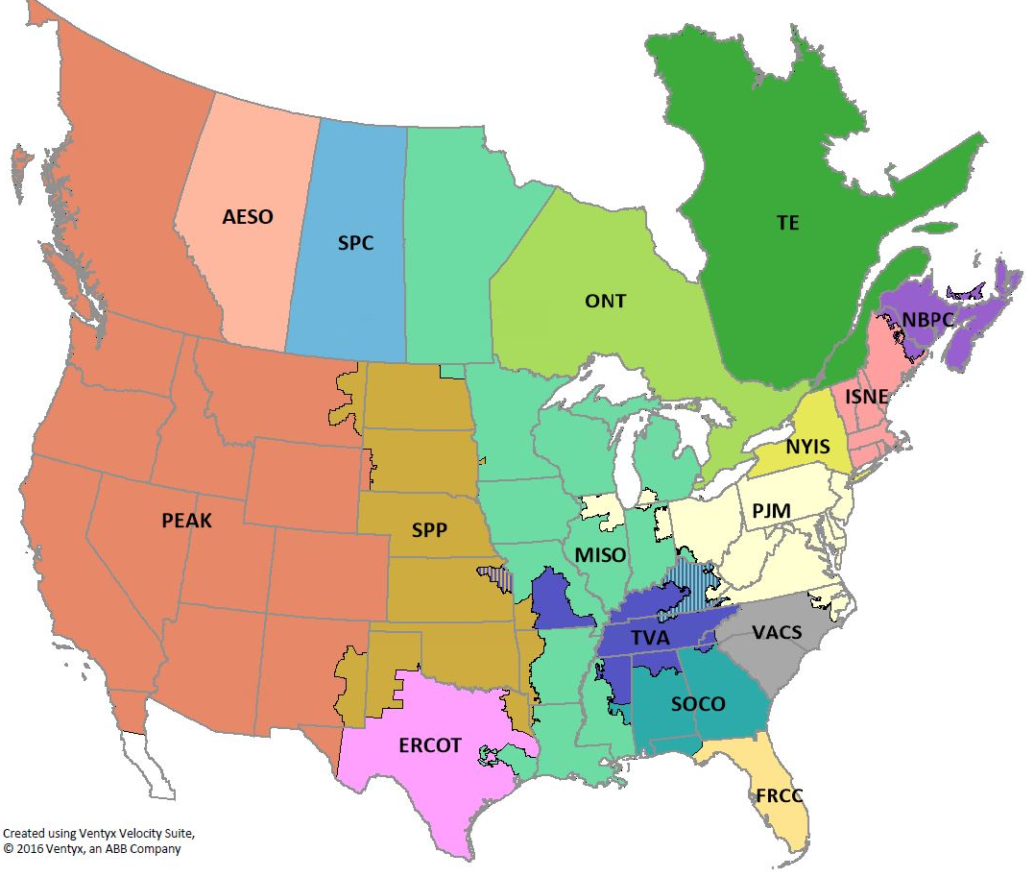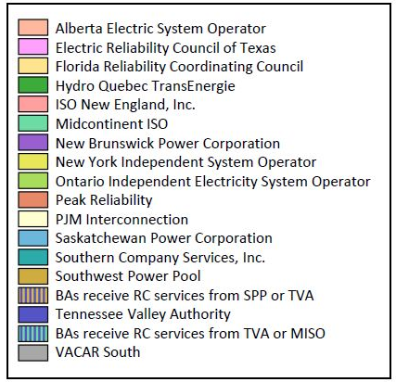
Source: North American Electricity Reliability Corporation (NERC)
As indicated in Figure 1, the United States and Canada are divided into 18 NERC control areas. FERC regulations and the rules and procedures followed by regional transmission operators (RTOs), independent system operators (ISOs), and non-aligned vertically integrated utilities must comply with NERC’s reliability standards. This includes rules and procedures covering the operation and market relations of power systems, such as dispatch and curtailment rules. Figure 2 shows the hierarchy of this enabling environment.

Figure 2: U.S. / Canada Enabling Environment
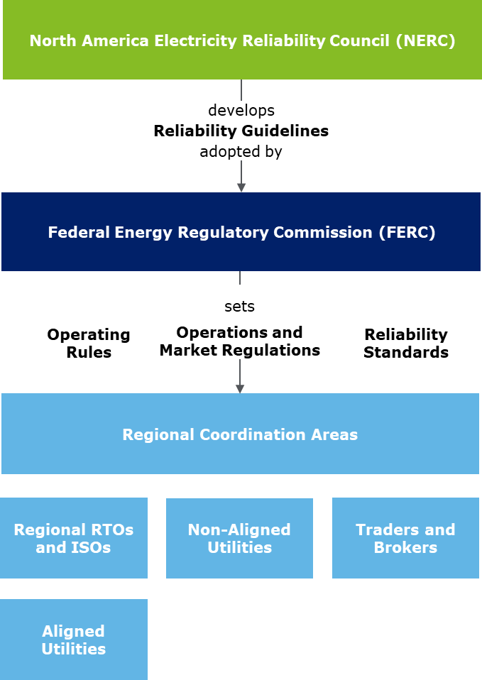
Table 1 provides an overview of selected NERC reliability standards that impact the operation of interconnectors within the United States and Canada and describes why these standards were adopted. A complete list of NERC’s standards can be found in the organization’s website.

Table 1: Selected NERC Reliability Standards
 | Standard | Contents | Notes
1. | Resource and demand balancing | Establishes that states/control areas must ensure outage coverage and not depend on interconnectors for balancing their own system. | None.
2. | Communications | Mandates that information must flow from key substations and generating facilities to the utility’s dispatch center and to the control area operator. | In the past, short-term maintenance and canceled or delayed maintenance of interconnectors was not communicated to the control area operators.
3. | Critical infrastructure protection | Establishes protection schemes to mitigate risk of outside interference (hacking) in the operation of electricity networks. | Cyber security has become a major issue for U.S. utilities regarding the interference with information related to the operation of interconnectors.
4. | Emergency preparedness and operations | Mandates that regional operators must have 32 hours of emergency training, including training on simulators. | This standard was recently updated after large interconnectors disconnected, creating cascades across wide North America (New York City, Northeast US, First Energy, etc.).
5. | Facilities design, connections, and maintenance | Establishes standards for facility construction, including interconnectors, and sets deadlines by which non-compliant facilities must be upgraded. | New additions to the electricity network were built to comply with different rules and regulations, and the equipment and practices used at new facilities could vary widely. As the real-time balancing areas grew, regional operators struggled with different approaches to connection, operations, and maintenance.
6. | Interchange scheduling and coordination | Includes specific requirements for establishing operating reserves on interconnectors, allocation of interconnector capacity, and the provision of scheduling information to market players and control area operators. | Transmission dispatch, and interconnector scheduling has improved due to the introduction and improvement of forecasting variable renewable energy. Wind speed and wind power calculations were introduced in the last 15 years or so.
7. | Interconnector reliability operations and coordination | Establishes rules for interconnector reliability across the control areas. For example, the level of interconnector capacity for operational reserve must be calculated on a regional basis, and not solely between the two interconnected parties. | In the 1970s, large utilities that shared interconnectors negotiated between themselves the terms and conditions of the interconnector’s operations and maintenance. After large outages in the eastern part of the United States, FERC decided that individual agreements on the interconnectors would not suffice and mandated specific rules covering the interconnectors.
8. | Modeling, data, and analysis | Mandates data reporting to NERC and the regional coordinators. NERC committees review and provide comments on modeling results. | Obtaining accurate data and reaching agreement on how to consistently model the system across NERC was difficult as utilities developed their own internal models. The planning models used by the utilities and regional operators were simple and quite different from each other, so the NERC and the regional operators invested into more flexible and more detailed models that could better represent the impacts on the systems from disturbances.
9. | Nuclear | Sets standards for the unique operational characteristics of nuclear power plants, which must be taken into consideration when modeling and scheduling system operation. | The inflexibility (must-run) of U.S. nuclear power plants to ramp down during low power periods created the need to ship large amounts of energy across critical interconnectors.
10. | Personnel performance, training, and qualifications | Mandates extensive training programs for all system operators, substation operators, and generators operators to reach a defined level of competence across North America. Violations for non-compliance of these standards can reach US$ 1 million/day. | The value of economic loss during some of the major outages in North America reached the US$ billions. Such losses provided incentives for the utility managers to ensure relevant personnel are certified.
11. | Protection and control | States that criteria and procedures for under-frequency control load shedding, contingency reserve requirements, disturbance monitoring equipment, and relay operational reporting and analysis must be specified on a regional basis. | Regional harmonization of these procedures avoids having a state or utility that is unable to recover from a system event (failure), which could result in overloading of interconnectors and requiring support from neighboring control areas. Several events in the United States resulted in cascading interruptions because of lack of proper controls.
12. | Transmission operations | Provides specific rules relating to the operation of transmission facilities, specifically related to interconnector protection. | In the mid 2000’s, the transmission system suffered from an aging workforce and decreasing equipment availability. Compliance became an important element for FERC for improved transmission operations, since non-compliance was penalized through large monetary fines. Smart metering and smart transmission equipment was added to the grid to better manage the transmission networks and increase collection of information on a real-time basis. Over 7 GW of demand response resources (interruptible demand) were added to NERC’s control area in recent years as a new, quick response resource for the transmission operators.
13. | Transmission planning | Sets planning requirements for medium and long-term expansion of the transmission system. | Increased renewable energy resources, such as wind and solar, initially presented challenges to the management of interconnectors as weather patterns have a material impact on the generation output levels within certain locations on the transmission system. Expansion of interconnector capacity, provided through capacity auctions for congested interconnectors, has relieved the congestion and this has become less of issue for NERC.
14. | Voltage and reactive power | Sets standards for voltage and reactive power, which are adopted by FERC and mandated to all electricity sector entities. | In the past, NERC provided general guidelines for voltage and reactive control, much of which was to be performed at end-user locations. End-users were provided with the option to either install equipment or pay penalties.  Payment of penalties was a short-term solution for industries but created too many problems for utilities as air conditioning and other similar demand increased rapidly. As a result, specific voltage and reactive power standards became mandatory for all utilities and industries were required to install capacitors or reactors in their substations if voltage support by the utility was a recurring event.

ENTSO-E (Europe)
The structure of Europe’s electricity sector oversight is different from the structure in the United States and Canada. The European Commission (EC) mandates directives and regulations for all energy sector entities within the European Union (EU). The European Network Transmission System Operators for Electricity (ENTSO-E), which is comprised of the transmission system operators of most the countries in western Europe, develops network codes covering many issues including dispatch, communication, emergency operations, interconnector capacity allocation, congestion management, real-time balancing, and imbalance service. The Agency for Cooperation of the Energy Regulators (ACER), an advisory group with no official regulatory authority, supports both the EC and ENTSO-E in the development of these oversight mechanisms. Figure 3 below depicts this hierarchal structure.

Figure 3: European Union Enabling Environment
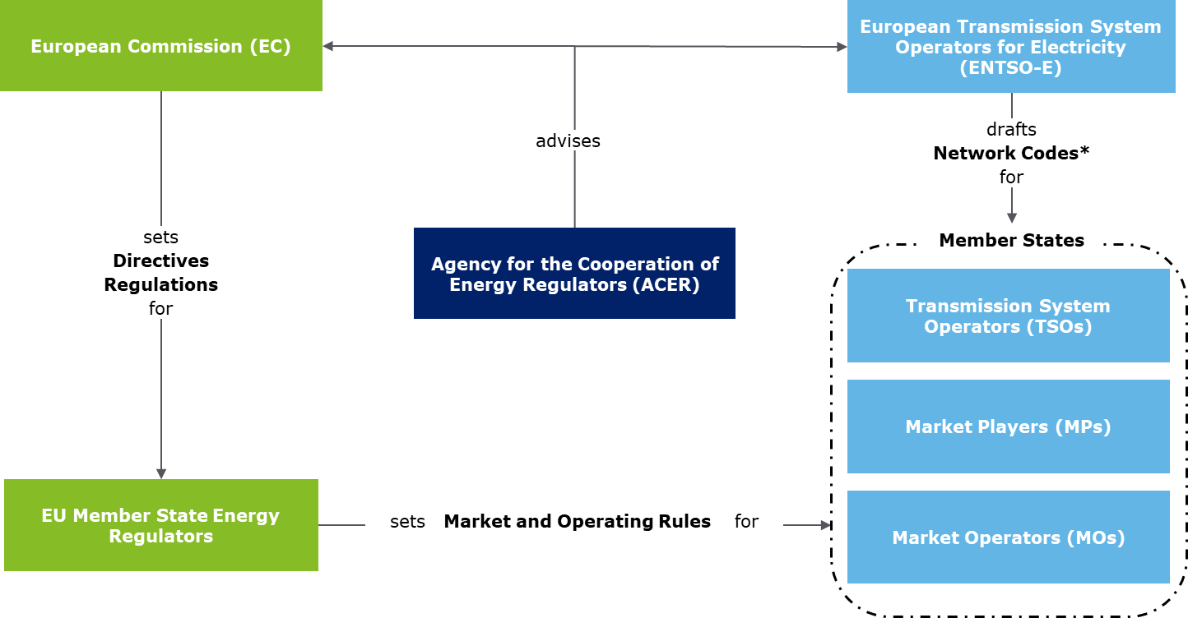
*ENTSO-E members include some non-EU Member States
There are similarities between the North American and European regulatory bodies, enabling environments, and the basic rules and operations of interconnectors. Table 2 provides an overview of ENTSO-E network codes (EU terminology for “standards”) that have an impact on the operation of interconnectors in its member states and describes why each code was put in place.

Table 2: ENTSO-E Network Codes
 | Network Code | Contents | Notes
Connections
1. | Requirements for Generators | Establishes harmonized standards that generators must comply with to connect to the grid. | These standards boost the market of generation technology and increase competitiveness.
2. | Demand Connection Code | Sets harmonized requirements for connecting large renewable energy production plants and demand response facilities. | This code is intended to ease the integration of 260 GW of photovoltaic and wind (almost tripling the current installed capacity in Europe) as well as 11 GW of demand response in Europe, which could replace the generation of 11 coal plants.
3. | High Voltage Direct Current Connections (HVDC) | Specifies requirements for long distance direct current (DC) connections used to link offshore wind parks to the mainland or connect countries over long distances. | For example, the longest existing interconnector in Europe, NorNed, links Norway and The Netherlands with a 580-km long HVDC submarine cable.
Operations
4. | Emergency and Restoration | Codifies the processes that TSOs must follow when they face an incident on their grid. | Western Europe suffered two large interconnector interruptions in the mid 2000’s – Switzerland to Italy, and Netherlands to France– that took days to recover. There was a lack of coordinated response to such interruptions.
5. | System Operations | Specifies what the obligations of TSOs in managing their grid including dispatching of generation, transmission, and demand response facilities. It lays the ground for the next power system. For example, it makes regional coordination a legal obligation for grid operators. | The generation mix in Europe includes an increasing percentage of renewables, number of interconnectors, and cross-border competition. The codes were updated to accommodate more diverse facilities and actions in the sector that impacted interconnector capacity and the need for more specific curtailment rules, such as including must-take contracts for renewable energy plant sales.
Market
6. | Forward Capacity Allocation | Establishes rules for long term (“forward”) markets, a key component that allows market participants to secure capacity on cross-border lines in advance and minimize the risk of financial loss. | Many interconnectors have been under-utilized in the past because state-owned utilities monopolized interconnector capacity. The new rules introduced non-discriminatory use of interconnector capacity.
7. | Capacity Allocation and Congestion Management | Sets out the methods for calculating how much capacity market participants may use on cross-border lines without endangering system security. | The rules on capacity allocation allow neighboring TSOs that share an interconnector to auction 50 percent of the export and 50 percent of the import capacity. In addition, the amount of reserve capacity on each interconnector goes through rigorous modeling by ENTSO-E to ensure that system security is maintained in emergency situations.
8. | Electricity Balancing | Establishes a market through which countries can share the resources used by their TSOs to consistently ensure generation is equal to demand, increase security of supply, limit emissions, and diminish costs to customers. | In the past, EU TSOs were responsible for operating the balancing markets within their operating control centers. With expanding interconnector capacity, the sharing of balancing resources became possible, although there are still concerns regarding how much reliance one operating control center should have on another.

Identification and MITIGATION of dispatch and curtailment risk
There are a range of circumstances that necessitate curtailment, all related to system adequacy:
  - Lack of dispatch flexibility;
  - Excessive amounts of bilateral power agreements;
  - Lack of resource adequacy on one or both sides of an interconnector;
  - Excessive amount of firm power contracts;
  - Lack of interconnector capacity;
  - Insufficient levels of operating reserves; and
  - Non-compliance with dispatch orders.
Even though curtailments take place in real time, they result from a lack of standards and their implementation. The probability of interconnector curtailment is high if procedures for risk mitigation are not followed. This was the case in the United States and Europe in the late 1990s and early 2000s, when such regulations were not obligatory and the risks from increased trading activity also increased.
Table 3 provides a list of dispatch and curtailment risks organized by time horizon, mitigation measures that must be carried out to address these risks, and the electricity sector entities responsible for carrying out the measures.

Table 3: System Adequacy Activity Timeline
Time Horizon | Dispatch and Curtailment Risk | Mitigation Measures | Responsible Parties
Long-term (1-30 years) | - Excessive must-run generation  - Excessive priority dispatch units (renewables) | - Establish energy policy and interconnector expansion strategy. | Country government and ministry responsible for energy issues.
 |  | - Conduct regional planning and development of interconnector capacity additions. | SAPP CC, RERA, Utility Planning Group or its TSO.
 |  | - Conduct regional planning and development of generation capacity additions. | SAPP CC, RERA, Utility Planning Group or TSO.
 |  | - Develop reliability and resource adequacy standards. | SAPP CC, RERA, country government, ministry responsible for energy issues or energy regulator.
 |  | - Develop market rules. | SAPP CC, RERA, national energy regulator, market operator (MO) or ministry responsible for energy issues.
Short term (1-52 weeks) | - Limited Demand Resources  - Lack of Reserve Capacity  - Pressure to release more interconnector capacity  - Excessive firm contracts across the interconnectors | - Conduct annual outage planning for transmission facilities. | SAPP CC, utility short-term planners or TSO.
 |  | - Conduct annual outage planning for generation facilities. | SAPP CC, utility short-term planners or TSO.
 |  | - Determine available interconnector capacity. | SAPP CC, utility short-term planners or TSO.
 |  | - Conduct annual and monthly auctions of interconnector capacity. | Utility procurement department or TSO.
Weekly Scheduling (next 7 days) | - Limited Demand Resources  - Lack of Reserve Capacity  - Pressure to release more interconnector capacity  - Excessive firm contracts across the interconnectors | - Perform scheduling for large hydro storage. | Large hydro project owner or TSO.
 |  | - Perform scheduling for transmission outages. | Utility dispatcher or TSO.
 |  | - Conduct weekly auctions of interconnector capacity. | Utility dispatcher or TSO.
Day-Ahead Market (DAM, 8-32 hours) | - Lack of balancing resources  - Over-subscription of interconnector capacity | - Conduct daily auctions of interconnector capacity. | Utility dispatcher or TSO.
 |  | - Establish balancing requirements and contracting for balancing resources (generation and demand). | Utility dispatcher or TSO.
 |  | - Conduct counter-trading. | Regional MO.
Intra-Day Market (IDM, 1-7 hours) | - Lack of balancing resources  - Over-subscription of interconnector capacity | - Adjust trading schedules and balancing resources, if needed. | Utility dispatcher or TSO.
Dispatch (real time) | - Generation outages on both sides of an interconnector  - Pool to-pool event | - Dispatch generation and transmission facilities. | Utility dispatcher or TSO.
Post-event (post real-time) | - Refusal by market players to reduce trades/generation production or increase generation production as required to reduce flow on an interconnector. | - Perform incident data collection and reporting.  - Perform non-compliance identification.  - Impose sanctions for non-compliance. | Utility dispatcher or TSO.
Settlement (up to 45 days after real time) | - Over or under supply or over or under demand as specified in the DAM and IDM. | - Make payments to balancing resources.  - Make payments for imbalance services,  - Adjust counter-trading | TSO and MO.

PROPOSED dispatch and curtailment risk GUIDELINES
The following guidelines are recommendations that address the major issues related to dispatch and curtailment risk. Drawing from the practices of NERC and ENTSO-E discussed in Section 2, they are intended to serve as a starting point from which RERA and SAPP should develop more detailed guidelines that would strengthen regional electricity trade while maintaining reliability and reflecting the conditions of the regional power sector.
Southern Africa Power Pool Guidelines for Access to the Network for Cross -Border Exchange in Electricity
Article 1. Establishment of network regulations
- RERA, after consulting with SAPP and other relevant stakeholders, will establish an annual priority list identifying the areas set out in Article 3 to be included in the development of network codes.
- RERA will develop non-binding framework guidelines (framework guidelines) setting out clear and objective principles, in accordance with Article 3, for the development of network codes relating to the areas identified in the priority list. Each framework guideline shall contribute to non-discrimination, effective competition, and the efficient functioning of the market.
- RERA shall formally consult with SAPP and all relevant stakeholders during development of the framework guidelines, for a period of no less than two months, in an open and transparent manner.
- If the SADC considers that the framework guidelines do not contribute to non-discrimination, effective competition and the efficient functioning of the market, it may request RERA to review the framework guidelines within a reasonable period of time and re-submit them to the SADC.
- If RERA fails to submit or re-submit the framework guidelines within the period set by the SADC, the SADC shall move forward with implementation of the framework guidelines in question.
- SAPP will submit a requested regulation which is in line with the relevant framework guidelines to RERA within a reasonable period of time not exceeding 12 months.
- Within a period of three months of the day of the receipt of a network code, during which RERA may formally consult the relevant stakeholders, RERA shall provide a reasoned opinion to the SAPP on the network code.
- SAPP may amend the network code in light of the opinions of RERA and re-submit it to RERA for approval.
- In the event SAPP has failed to develop a network code within the period of time set by SAPP, RERA may prepare a draft network code on the basis of the relevant framework guideline. RERA may launch a further consultation in the course of preparing a draft network code under this paragraph. RERA shall submit a draft network code prepared under this paragraph to the SADC and may recommend that it be adopted.
- The SADC may adopt a network code on its own initiative in the event SAPP has failed to develop a network code, or RERA has failed to develop a draft network code.
- Where the SADC proposes to adopt a network code on its own initiative, the SADC shall consult RERA, SAPP and all relevant stakeholders on the draft network code during a period of no less than two months. Those measures, designed to amend non-essential elements of this Regulation by supplementing it, shall be adopted in accordance with the regulatory procedure with scrutiny.
- This Article shall be without prejudice to the SADC’s right to adopt and amend the Guidelines.
Article 2. Responsiblities of the SAPP
- SAPP shall develop network codes in the areas referred to in Article 1 upon RERA's request.
- SAPP may develop new regulations to achieve the objectives set out in Article 1 where those new regulations do not relate to areas addressed by RERA. Any such regulations shall be submitted to RERA for an opinion. That opinion shall be duly considered by SAPP.
- SAPP shall adopt:
  - common network operation tools to ensure coordination of network operation in normal and emergency conditions, including a common incidents classification scale, and research plans;
  - a non-binding pool-wide ten-year network development plan, (pool-wide network development plan), including a generation adequacy outlook, every two years;
  - recommendations relating to the coordination of technical cooperation between SAPP and third-country transmission system operators;
  - an annual work plan;
  - an annual report;
  - annual summer and winter generation adequacy outlooks.
- The generation adequacy outlook referred to in point (b) of paragraph 3 shall cover the overall adequacy of the electricity system to supply current and projected demand for electricity for the next five-year period as well as for the period between five and 15 years from the date of that outlook. The generation adequacy outlook shall build on national generation adequacy outlooks prepared by each individual transmission system operator.
- The annual work plan referred to in point (d) shall contain a list and description of the network codes to be prepared, a plan on coordination of operation of the network, and research and development activities, to be realized in that year, and an indicative calendar.
- The network codes referred to in paragraphs 1 and 2 shall cover the following areas, considering, if appropriate, regional specificities:
  - network security and reliability rules including rules for technical transmission reserve capacity for operational network security;
  - network connection rules;
  - third-party access rules;
  - data exchange and settlement rules;
  - interoperability rules;
  - operational procedures in an emergency;
  - capacity-allocation and congestion-management rules;
  - rules for trading related to technical and operational provision of network access services and system balancing;
  - transparency rules;
  - balancing rules including network-related reserve power rules;
  - rules regarding harmonized transmission tariff structures including locational signals and inter-transmission system operator compensation rules; and
  - energy efficiency regarding electricity networks.
- The network codes shall be developed for cross-border network issues and market integration issues and shall be without prejudice to the Member States’ right to establish national network codes which do not affect cross-border trade.
- SAPP shall monitor and analyze the implementation of the network codes and their effect on the harmonization of applicable rules aimed at facilitating market integration. SAPP shall report its findings to RERA and shall include the results of the analysis in the annual report referred to in this Article.
- SAPP shall make available all information required by RERA to fulfill its obligations under these guidelines.
- SAPP shall adopt and publish a pool-wide network development plan every two years. The pool-wide network development plan shall include the modelling of the integrated network, scenario development, a generation adequacy outlook and an assessment of the resilience of the system.
- The pool-wide network development plan shall, in particular:
  - build on national investment plans, considering regional investment plans, and, if appropriate, pool aspects of network planning including the guidelines for trans-region energy networks;
  - regarding cross-border interconnectors, also build on the reasonable needs of different system users and integrate long-term commitments from investors; and
  - identify investment gaps, notably with respect to cross-border capacities.
- Regarding point (c), a review of barriers to the increase of cross-border capacity of the network arising from different approval procedures or practices may be annexed to the pool-wide network development plan.
- RERA shall provide an opinion on the national ten-year network development plans of Member States to assess their consistency with the pool-wide network development plan. If RERA identifies inconsistencies between a national ten-year network development plan and the Pool-wide network development plan, it shall recommend amending the national ten-year network development plan or the pool-wide network development plan as appropriate.
Article 3. Monitoring by RERA
- RERA shall monitor the execution of the tasks of the SAPP specified under these guidelines.
- RERA shall monitor SAPP's implementation of network codes. Where SAPP has failed to implement such network codes, RERA shall request SAPP to provide a duly reasoned explanation as to why it has failed to do so.
- RERA shall monitor and analyze the network codes' effect on the harmonization of applicable rules aimed at facilitating market integration as well as on non-discrimination, effective competition and the efficient functioning of the market, and report to the SADC.
- SAPP shall submit the draft pool-wide network development plan, the draft annual work program, including the information regarding the consultation process and other required documents within this Guideline to RERA for its opinion.
- Within two months from the day of receipt, RERA shall provide a duly reasoned opinion, as well as recommendations to the SAPP, regarding the draft annual work program or draft pool-wide network development plan submitted by the SAPP in instances in which RERA believes plans do not contribute to non-discrimination, effective competition, the efficient functioning of the market or a sufficient level of cross-border interconnector open to third-party access.
Article 4. Regional cooperation of transmission system operators (TSOs)
- TSOs shall establish regional cooperation within the SAPP to contribute to the activities referred to in these guidelines. They shall cooperate with the SAPP in developing a regional investment plan every two years, and may take investment decisions based on that regional investment plan.
- TSOs shall promote operational arrangements to ensure the optimum management of the network and shall promote the development of energy exchanges, the coordinated allocation of cross-border capacity through non-discriminatory market-based solutions, paying due attention to the specific merits of implicit auctions for short-term allocations, and the integration of balancing and reserve power mechanisms.
Article 5. Management and Allocation of Available Transfer Capacity of Interconnectors Between National Systems
- TSOs shall endeavor to accept all commercial transactions, including those involving cross-border trade.
- Market participants will secure long-term firm physical transmission rights (PTRs) for their long-term power sales and purchases transactions, subject to Article 12 paragraph 1.
- For available capacity on each interconnector, SAPP will auction [ ] percent on an annual basis. SAPP will auction [ ] percent of each interconnector on a monthly basis. Any available capacity that was due to be auctioned but remains unallocated will become available on a monthly basis as well.
- A certain percentage of the capacity under short-term PTRs of each interconnector will be reserved for short-term energy transactions through the power exchange subject to Article 12, paragraph 2. National TSOs will propose the percentage and will seek an opinion from SAPP and RERA to ensure sufficient capacity is allocated to short-term PTRs that results in a viable power exchange. To the extent any unallocated capacity is available after the monthly auction or under the Use-It-Or-Lose-It (UIOLI) approach, then such capacity willl also be available for the DAM.
- At least [50 percent] of the revenues from the interconnector capacity auctions will be used to fund the expansion of the respective interconnector capacity.
- The national transmission system operators may offer non-firm physical transmission rights to allow maximum use of the interconnector. The PTR holders of non-firm transmission rights will pay a lower price for non-firm service considering that the service may be interrupted and backup arrangements must be organized by the selling and/or purchasing market participants.
- When there is no congestion, there shall be no restriction of access to the interconnector. Where this is usually the case, there does not need to be a permanent general allocation procedure for access to a cross-border transmission service.
- Where scheduled commercial transactions are not compatible with secure network operations, the TSOs shall alleviate congestion in compliance with the requirements of network operational security while endeavoring to ensure that any associated costs remain at an economically efficient level.
- If structural congestion appears, appropriate congestion-management methods and arrangements defined and agreed upon in advance shall be implemented immediately by the TSOs. The congestion-management methods shall ensure that the physical power flows associated with all allocated transmission capacity comply with network security standards.
- The methods adopted for congestion management shall give efficient economic signals to market participants and TSOs, promote competition, and be suitable for regional and pool-wide application.
- No transaction-based distinction shall be applied in congestion management. A particular request for transmission service shall be denied only when the following cumulative conditions are fulfilled:
  - the incremental physical power flows resulting from the acceptance of that request imply that secure operation of the power system may no longer be guaranteed; and
  - the monetary value of the request in the congestion-management procedure is lower than all other requests intended to be accepted for the same service and conditions.
- When defining appropriate network areas in and between which congestion management is to apply, TSOs shall be guided by the principles of cost-effectiveness and minimization of negative impacts on the internal electricity market. Specifically, TSOs shall not limit interconnector capacity in order to address congestion inside their own control area, save for the abovementioned reasons and reasons of operational security.
- Operational security refers to the need to maintain the transmission system within agreed security limits, which shall be described and transparently presented by the TSOs to all the system users. Limiting interconnector capacity due to domestic congestion can be tolerated only until a long-term solution is found. The methodology and projects for achieving the long-term solution shall be described and transparently presented by the TSOs to all the system users.
- When balancing the network inside the control area through operational measures in the network and through re-dispatching, the TSO shall consider the effect of those measures on neighboring control areas.
- Mechanisms for the intra-day congestion management of interconnector capacity shall be established in a coordinated way and under secure operational conditions, in order to maximize opportunities for trade and to provide for cross-border balancing.
Article 6. Provision of information
- Transmission system operators shall put in place coordination and information exchange mechanisms to ensure the security of the networks in the context of congestion management.
- The safety, operational, and planning standards used by TSOs shall be made public. The information published shall include a general scheme for the calculation of the total transfer capacity and the transmission reliability margin based upon the electrical and physical features of the network. Such schemes shall be subject to the approval of the regulatory authorities.
- TSOs shall publish estimates of available transfer capacity for each day, indicating any available transfer capacity already reserved. Those publications shall be made at specified intervals before the day of transport and shall include, in any event, week-ahead and month-ahead estimates, as well as a quantitative indication of the expected reliability of the available capacity.
- TSOs shall publish relevant data on aggregated forecast and actual demand, on availability and actual use of generation and load assets, on availability and use of the networks and interconnectors, and on balancing power and reserve capacity. For availability and actual use of small generation and load units, aggregated estimate data may be used.
- The market participants concerned shall provide TSOs with the relevant data.
- Generation plants, where at least one generation asset has an installed capacity of at least [ ] MW, shall keep at the disposal of the national regulatory authority and the SAPP, for five years, all hourly data per plant that is necessary to verify all operational dispatching decisions and the bidding behavior at power exchanges, interconnector auctions, reserve markets and over-the-counter-markets. The per-plant and per hour information to be stored shall include, but shall not be limited to, data on available generation capacity and committed reserves, including allocation of those committed reserves on a per-plant level, at the times the bidding is carried out and when production takes place.
Article 7. Regulatory authorities
- The national regulatory authorities, when carrying out their responsibilities, shall ensure compliance with these guidelines. Where appropriate to fulfill the aims of these guidelines, the national regulatory authorities shall cooperate with each other, and RERA.
Article 8. Provision of information and confidentiality
- Member States and the regulatory authorities shall, on request, provide to RERA all information necessary for the purposes of these Guidelines.
- National regulatory authorities shall, on a regular basis, provide information on the actual costs incurred by national TSOs, as well as data and all relevant information relating to the physical flows in transmission system operators’ networks and the cost of the networks.
- RERA shall fix a reasonable time limit within which the information is to be provided, considering the complexity of the information required and the urgency with which the information is needed.
- If the Member State or the relevant national regulatory authority does not provide the requested information within the given time-limit, RERA may request all information necessary directly from the energy sector entity concerned.
- When sending a request for information to an energy sector entity, RERA shall at the same time forward a copy of the request to the national regulatory authorities of the Member State in whose territory the energy sector entity is situated.
- In its request for information, RERA shall state the legal basis of the request, the time-limit within which the information is to be provided, the purpose of the request, and the penalties provided for in Article 13 for supplying incorrect, incomplete or misleading information. RERA shall fix a reasonable time-limit considering the complexity of the information required and the urgency with which the information is needed.
- The owners of the energy sector entities or their representatives and, in the case of legal persons, the persons authorized to represent them by law or by their instrument of incorporation, shall supply the information requested. Where an authorized third party supplies the information on behalf of their clients, the client shall remain fully responsible in the event that the information supplied is incomplete, incorrect or misleading.
- Where an energy sector entity does not provide the information requested within the time-limit or supplies incomplete information, RERA may by decision require the information to be provided. That decision shall specify what information is required and fix an appropriate time-limit within which it is to be supplied. It shall indicate the penalties provided for in Article 13.
- RERA shall, at the same time, send a copy of its decision to the regulatory authorities of the Member State within the territory of which the person is resident or the seat of the undertaking is situated.
- The information shall be used only for the purposes of fulfilling the requirements of these guidelines.
- RERA shall not disclose information acquired pursuant to these guidelines of the kind covered by the obligation of professional secrecy.
Article 9. Right of Member States to provide for more detailed measures
- These Guidelines shall be without prejudice to the rights of Member States to maintain or introduce measures that contain more detailed provisions than those set out herein.
Article 10. Penalties
- The SADC shall establish rules on penalties applicable to infringements of the provisions of these guidelines and shall take all measures necessary to ensure that those provisions are implemented. The penalties provided for must be effective, proportionate and dissuasive. The Member States shall notify RERA of those rules within [ ] days and shall notify RERA without delay of any subsequent amendment affecting them. Member States shall notify RERA of non-compliant rules and shall notify RERA without delay of any subsequent amendment affecting them.

- RERA may, by decision, impose fines not exceeding [ ] percent of the total turnover in the preceding business year where, intentionally or negligently, any power sector entity supplies incorrect, incomplete or misleading information in response to a request from RERA or fail to supply information within the time-limits set by these guidelines.

- In setting the amount of a fine, RERA shall consider the gravity of the failure to comply with the requirements.
- Penalties provided for and decisions taken by RERA shall not be of a criminal nature.
Article 11. SADC Report
- The SADC shall monitor the implementation of these guidelines. RERA shall report annually on the experience gained in the application of these guidelines. In particular the report shall examine to what extent these guidelines have been successful in ensuring non-discriminatory and cost-reflective network access conditions for cross border exchanges of electricity in order to contribute to customer choice in a well-functioning market in electricity and to long-term security of supply, as well as to what extent effective locational signals are in place. If necessary, the report shall be accompanied by appropriate proposals and/or recommendations.
Article 12. Transitional Provisions
- The interconnector capacity allocation (PTRs) for long-term contracts in place on [DATE] will be grandfathered until [DATE].
- The amount of interconnector capacity allocated to the DAM will vary by interconnector. At least five percent of interconnector capacity will be allocated to the DAM by 01/01/2020 and at least ten percent by 01/01/2025, except in situations restricted by the capacity allocation to grandfathered contracts referred to in paragraph 1.

Southern Africa Power Pool Guidelines for Curtailment During an Emergency
Article 1. Long-term Physical Transmission Rights
- Long-term (yearly and monthly) Physical Transmission Rights (PTRs) may be curtailed in the event of force majeure, or to ensure operation of transmission network remains within Operational Security Limits before the Day-Ahead Gate Closure.
- Long-term PTRs may be curtailed after the Day-Ahead Firmness Deadline (DAFD) in the case of force majeure or an emergency.
- In the case of Long-term PTRs, each PTR holder affected by curtailment shall lose its right to transfer, return or nominate for physical use the concerned PTRs or to receive remuneration based on the use it or sell it principle.
Article 2. Short-term Physical Transmission Rights
- Short-term (Daily) PTRs may be curtailed in the event of force majeure or an emergency according to applicable legislation.
- Curtailment may be applied on allocated Daily PTRs including, where the case may be, on nominated PTRs.
- Each PTR holder affected by curtailment shall lose its right to nominate for physical use the concerned Transmission Rights.
- In case of curtailment, the affected PTR holder is entitled to receive reimbursement or compensation.
- In all cases curtailment on Daily Transmission Rights shall be carried out by the SAPP based on a request by the transmission system operators.
Article 3. Curtailments
- SAPP will instruct TSOs to curtail interconnector flows.
- SAPP shall notify the affected holders of Long-term PTRs as soon as possible of a curtailment of Long-term PTRs including the triggering event via email and on the webpage of the SAPP. The notification shall identify the affected Long-term PTRs, the affected volume in MW per hour for each concerned period, the triggering events for curtailment and the amount of Long-term Transmission Rights that remain after the curtailment.
- SAPP shall publish the triggering events for curtailment including their estimated duration on its website as soon as possible.
- The national transmission system operator which requests the curtailment shall issue a description of reasons and effects of curtailment for solving network or system problems that will be published by both impacted national transmission system operators.
- PTRs’ curtailments or reduction of submitted Nominated PTRs shall have as reference a capacity multiple of 1 MW and time-period multiple of one hour.
- PTRs’ curtailment and/or reduction of submitted schedules shall be done in a non-discriminatory manner, meaning that yearly and monthly PTRs (including submitted schedules) shall be curtailed/reduced in the same way as the daily PTRs/submitted schedules.
Article 4. Compensation for Curtailment
- In case of curtailment, the PTR holder will be reimbursed or compensated.
- The curtailment shall be applied to Long-term PTRs of the concerned periods on a pro-rata basis, which means in proportion to the held Long-term Transmission Rights, regardless of the time of allocation.
- In the event of curtailments of Long-term PTRs after the nomination deadline, and as long as the capacity has not been reallocated in the day-ahead allocation, the curtailment shall be applied on a pro-rata basis to both nominated and not nominated PTRs.
- In the case of PTRs’ curtailment, the PTR holders whose PTRs have been curtailed, before the DAFD, shall be compensated by SAPP for the curtailed PTRs/schedules for each affected hour based on the auction price of the initial auction for the concerned hourly period.
- The value of compensation is calculated as curtailed PTRs in MW multiplied by hours of the curtailment multiplied by the market spread or auction price as it is mentioned above.
- If the curtailment occurs before the publication of daily auction results, the PTR holders will be compensated for both curtailed nominated and non-nominated PTRs;
- If the curtailment occurs after publication of daily auction results, the PTR Holders will be compensated for curtailed nominated PTRs;
- The compensation calculated according to above paragraphs which occurred within one calendar year shall be further subject to a cap. The cap shall be determined as the total amount of congestion income collected by transmission system operators (yearly, monthly and daily congestion income less remunerations done according to “use it or lose it” principle) on the respective bidding zones border in the relevant calendar year.
- If, before application of the relevant cap described in above paragraph of this Article, the total calculated compensations of curtailed PTRs exceed the relevant cap, the compensations of curtailed PTRs shall be reduced on a pro rata basis. This will be based on the proportion of uncapped compensation of allocated PTRs due to each PTR holder in the relevant period (calendar month or calendar year). The compensations due to each PTR holder will be calculated as follows:
  - [(Uncapped compensations of curtailed PTRs due to PTR holder)/ (Total uncapped compensations of curtailed PTRs due to all PTR holders)] x (relevant cap as described in above paragraph of this Article).
- SAPP shall notify the affected holders of Transmission Rights as soon as possible of a curtailment of Transmission Rights via email and on the webpage of SAPP. The notification shall identify the affected Transmission Rights, the affected volume in MW per hour for each concerned period, the triggering events for curtailment and the amount of Transmission Rights that remain after the curtailment.
- SAPP shall publish the triggering events for curtailment including their estimated duration on its website as soon as possible.
- The curtailment of Transmission Rights during a specific time period shall be applied to all Transmission Rights of the concerned periods on a pro rata basis, which means in proportion to the held Transmission Rights.
- For each affected PTR holder, remaining Transmission Rights which have not been curtailed shall be rounded down to the nearest MW.
Article 5. Compensation for Curtailment
- In case of curtailment applied no later than at DAFD, the PTR holders whose PTRs have been curtailed shall be compensated or reimbursed by SAPP for the curtailed PTRs for each affected hour, as follows:
  - In the case of an emergency situation with:
    - the auction price of the respective auction;
  - In the case of force majeure with:
    - ZAR Ø /MWh.
- The value of compensation is calculated as curtailed PTRs in MW multiplied by hours of the curtailment multiplied by the auction price for the respective hour as it is mentioned above.
- In case of curtailment published by SAPP on its website after DAFD the PTR holders whose PTRs have been curtailed shall be compensated or reimbursed by the auction operator for the curtailed daily PTRs/schedules for each affected hour as follows:
i. In the case of an emergency with:
- the market spread, in case the price difference is positive in the direction of the curtailed PTRs, and ZAR Ø /MWh, otherwise; or
- the auction price if the day-ahead price is not calculated at least in one of the two relevant bidding zones;
ii. In the case of force majeure with:
- the auction price of respective auction;

- The value of compensation is calculated as curtailed PTRs in MW multiplied by hours of the curtailment multiplied by the market spread or auction price for the respective hour as mentioned above.
Article 6. Settlement Notification
- The Settlement Notification due to the curtailment will be sent no later than the last calendar day of a month and will concern the curtailment produce in the previous month.
- After receiving the Settlement Notification but after no more than five (5) working days, the respective PTR holder shall issue an invoice to the effected national transmission system operator, with a maturity date of ten (10) working days. No later than the due date of the respective invoice, effected national transmission system operator will credit the bank account of the PTR holder with the respective amount.
- In case of curtailment compensation due to force majeure or an emergency situation, PTR holders shall not be entitled to other compensation than the compensation described in these guidelines.

Next Steps
These Dispatch and Curtailment Risk Guidelines provide a baseline of critical clauses, rights, and obligations that should be followed to provide effective treatment of dispatch and curtailment risk on cross-border interconnectors within SAPP.
Following the U.S. Department of State’s review, the Deloitte Team will share these Guidelines with RERA, who should then consult with SAPP and the Governments of Zambia, Namibia, and Botswana—the three pilot countries— to test their application on the planned ZIZABONA interconnector project. Once RERA approves these Guidelines, they may be presented to the SADC Directorate of Infrastructure and Services, who after further review and consideration, can table the Guidelines to the SADC Energy Ministers for adoption and use across Southern Africa.

North American Electric Reliability Corporation. “Reliability Standards for the Bulk Electric Systems of North America”. July 2018. https://www.nerc.com/pa/Stand/Reliability%20Standards%20Complete%20Set/RSCompleteSet.pdf
Specific information on the all rules, guidelines and regulations of the EU can be found at the EC’s website: https://ec.europa.eu/energy/en/topics/markets-and-consumers/wholesale-market/electricity-network-codes

